Wimygit Test Plan

|  |  |
| --- | --- |
| Application Name | wimygit |
| Application ID | APP_3166 |
| Application Version | NA |
| Application Install Location | \\appcompatsrv\Appcompat\DotNetCore\Apps\WimyGit |
| Source Install Location | https://github.com/zelon/wimygit |
| Application Priority | P3 |
| Technology | WPF |
| .NET Version | .NET Core 3.1 |
| Client Supported | Yes |
| Deployment | XCopy |
| Design Times usage (hours) | NA |

# History Log

|  |  |  |  |
| --- | --- | --- | --- |
| **No.** | **Date** | **Comments** | **Author** |
| 1 | 04/28/2020 | Create the test plan | v-wenjj |
| 2 | 04/29/2020 | Update the test plan | v-wenjj |
| 3 | 05/05/2020 | Update the test plan | v-wenjj |

# Configurations

Following configurations are tested in the manual phase:

|  |  |  |  |
| --- | --- | --- | --- |
| Config # | Platforms + NetFx | Target To | Comments |
| 1 | Windows 10 X64 + .NET Core 3.1 | Default version | Design test plan |
|  |  |  |  |

Table of Contents

History Log 1

Configurations 1

Summary 2

Pre-requisite s 2

Brief Introduction 2

Installation or Deployment 2

Uninstallation 2

Scenarios 3

Scenario 1: Test Push/Pull/FetchAll 3

Scenario 2: Test TimeLapse 22

Scenario 3: Test OpenFolder/Terminal/RemoteInfo 32

Scenario 4: Test Stash 45

Scenario 5: Test Amend Commit 57

Issues 73

# Summary

Following table shows scenarios tested for the app and their pass/fail status.

|  |  |  |  |
| --- | --- | --- | --- |
| Items | Test Case Title | Technology Description | Config #1 |
| Install | -- | -- | Pass |
| Uninstall | -- | -- | Pass |
| Look and feel | -- | -- | Pass |
| Performance | -- | -- | Pass |
| APP_3166_001 | Test Push/Pull/FetchAll |  | Pass |
| APP_3166_002 | Test TimeLapse |  | Pass |
| APP_3166_003 | Test OpenFolder/Terminal/RemoteInfo |  | Pass |
| APP_3166_004 | Test Stash |  | Pass |
| APP_3166_005 | Test Amend Commit |  | Pass |
| Issues |  |  |  |
| No issue |  |  |  |

# Pre-requisite s

|  |  |  |
| --- | --- | --- |
| **No.** | **Name** | **Comment** |
| 1 | .NET Core | Version 3.1 |
|  |  |  |
|  |  |  |

# Brief Introduction

Wimgit app offer a GUI which can pull/push/fetch code by click buttons, instead of writing command.

# Installation or Deployment

Copy all files from \\appcompatsrv\Appcompat\DotNetCore\Apps\WimyGit

to %APP_CLIENT_ROOT%\application\WimyGit folder.

# Uninstallation

NA

# Scenarios

## Scenario 1: Test Push/Pull/FetchAll

**Case ID:** APP_3166_001

**Test Steps:**

1. Launch appliciaton from “%APP_CLIENT_ROOT%\WimyGit\WimyGit.exe”.
2. Input the “%APP_CLIENT_SCRIPTSDIR%\AdditionFiles\wimygit\wimygit-test” link to input box.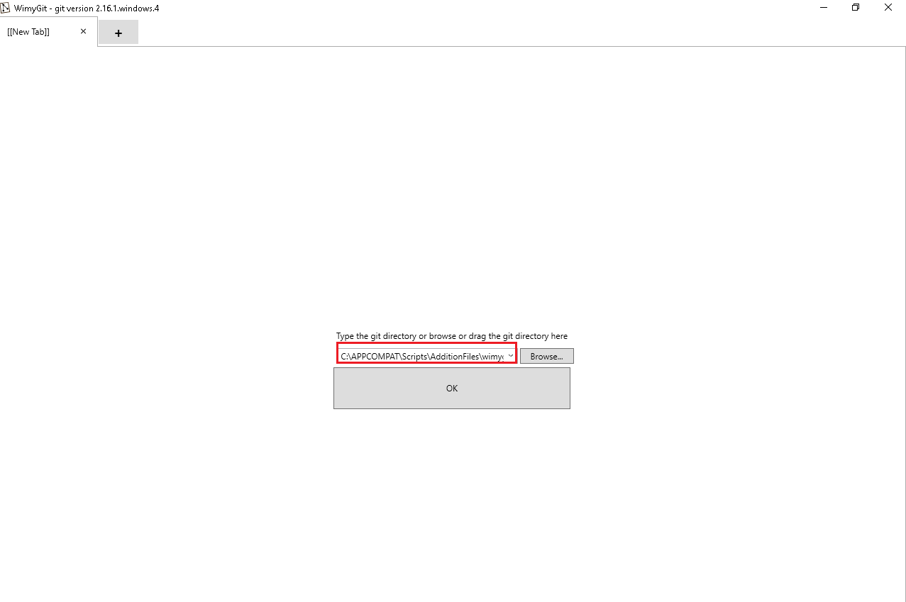
3. Press “OK” button.

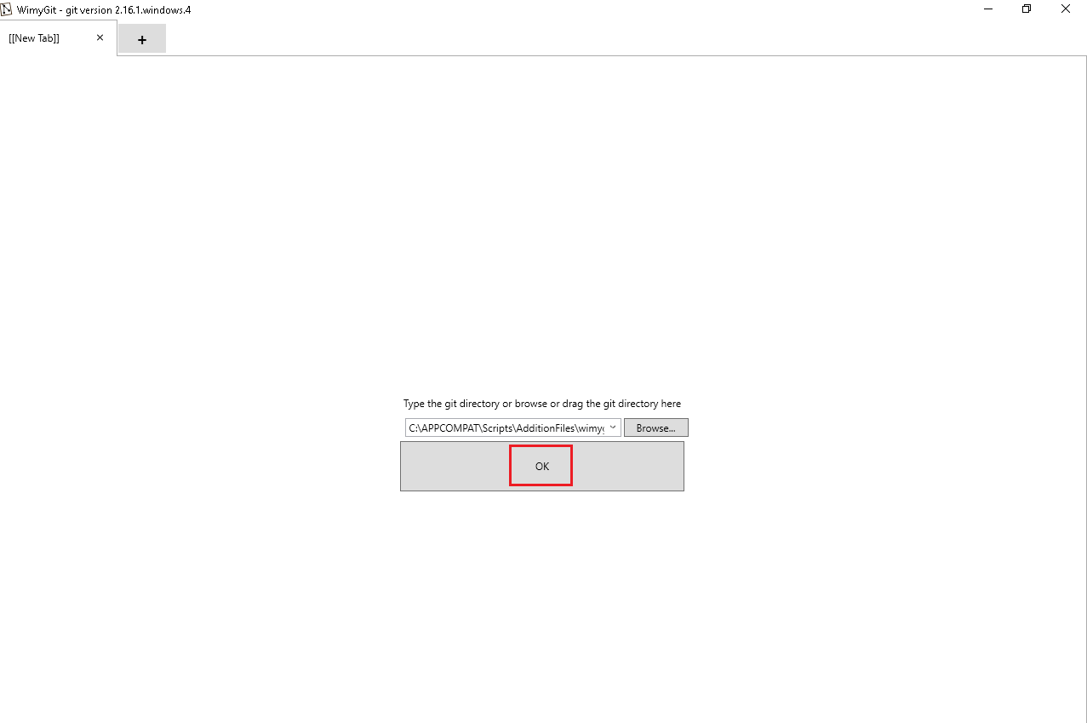

1. Select the file in unstaged files.

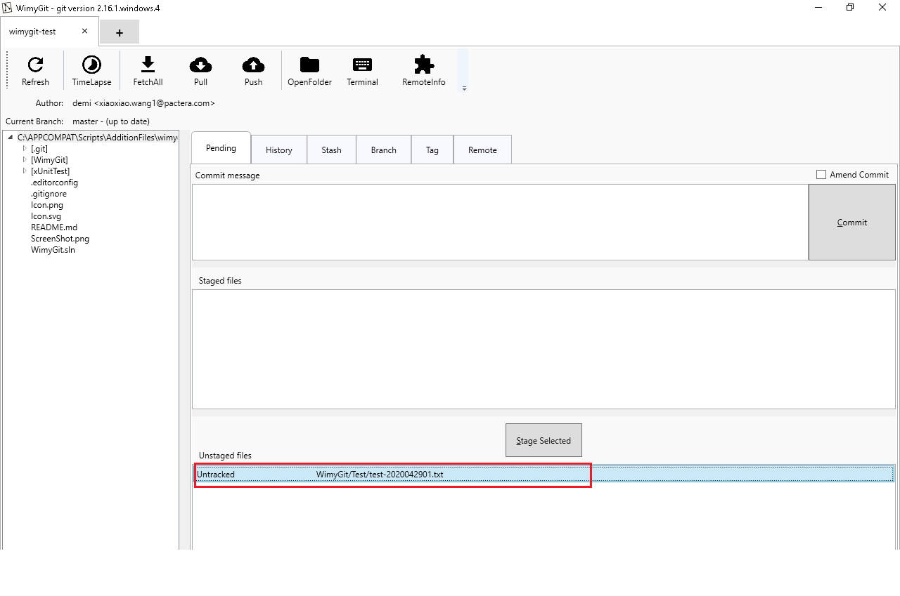

1. Click “Stage Selected” button.

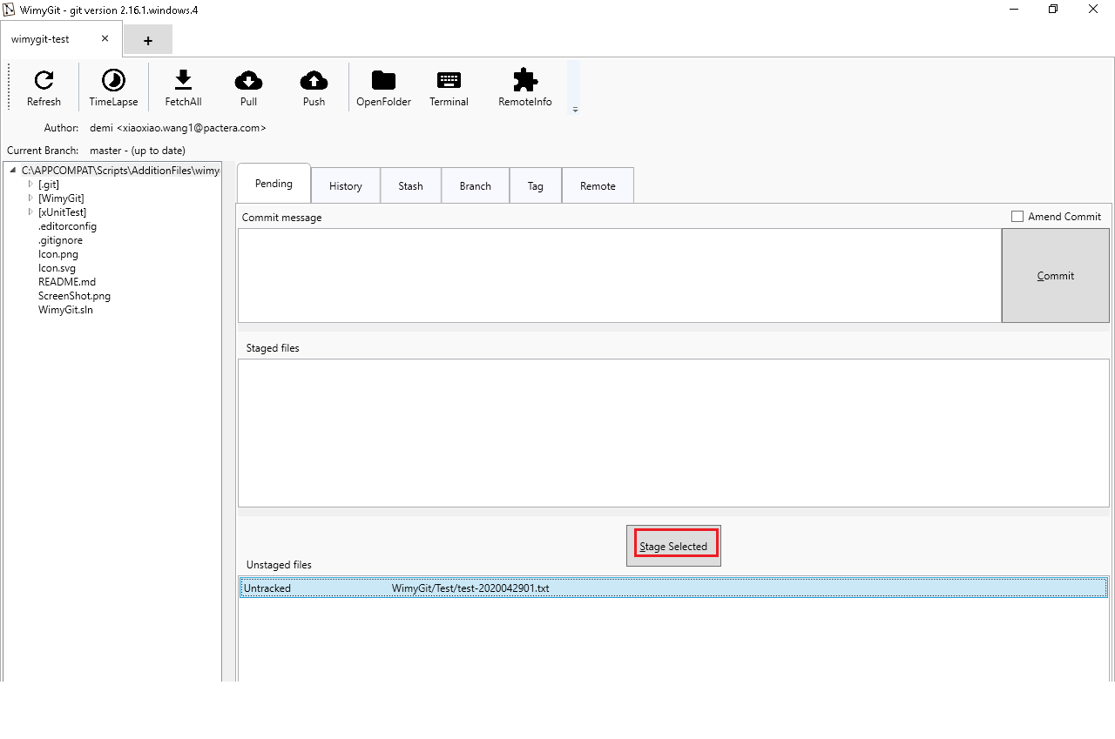

1. Input “Create a new file” message in commit box.

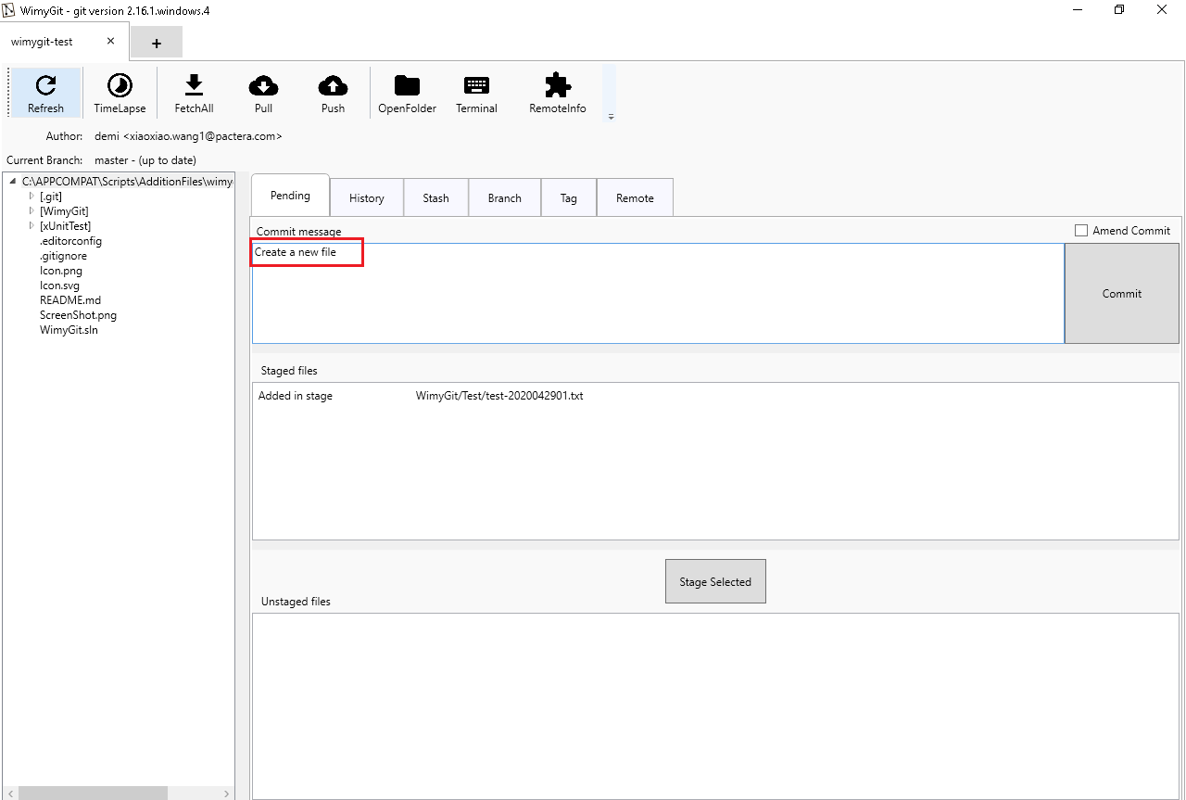

1. Click “Commit” button.

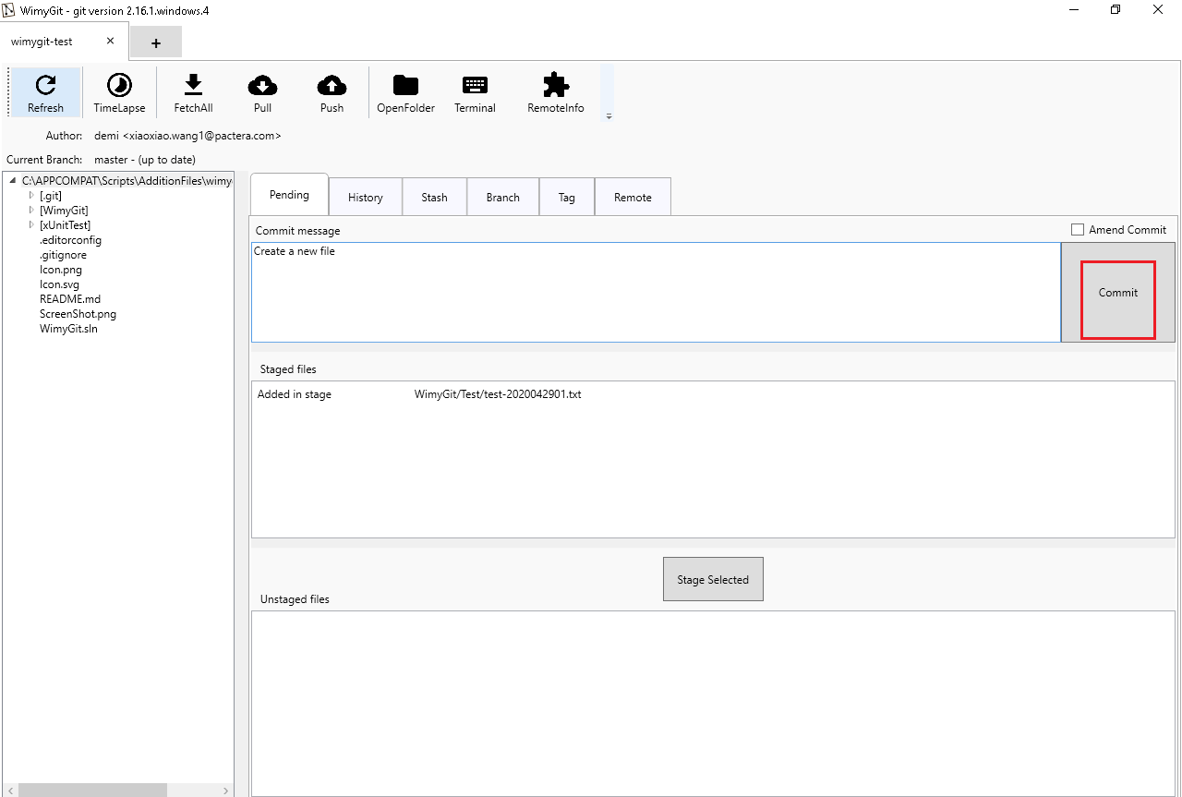

1. Click “Push” button.

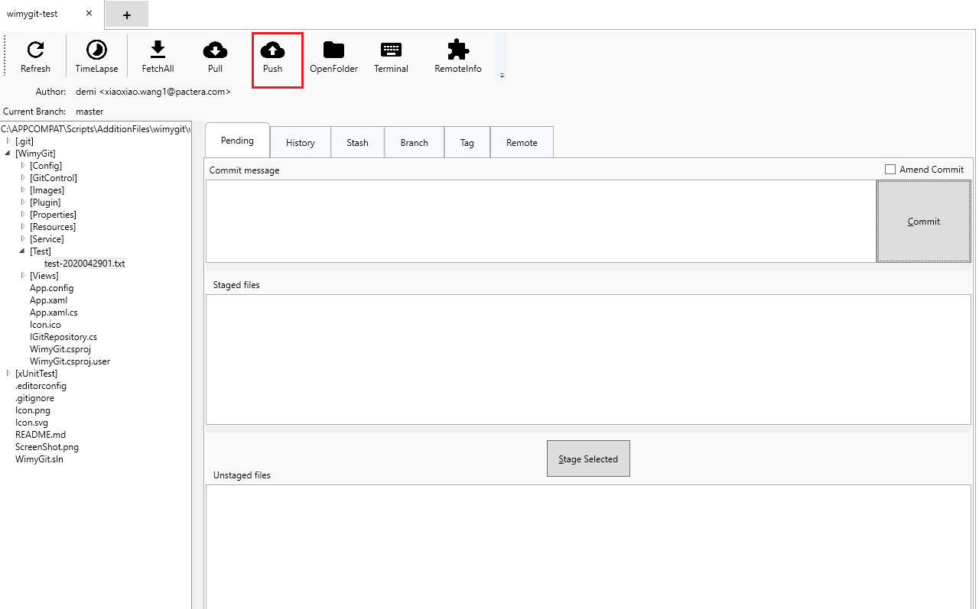

1. **Verify**: There is a “Process exited with success” stentence in the window (The modified content has been commited to remote server successfully).



1. Click “Close” button to close the window.

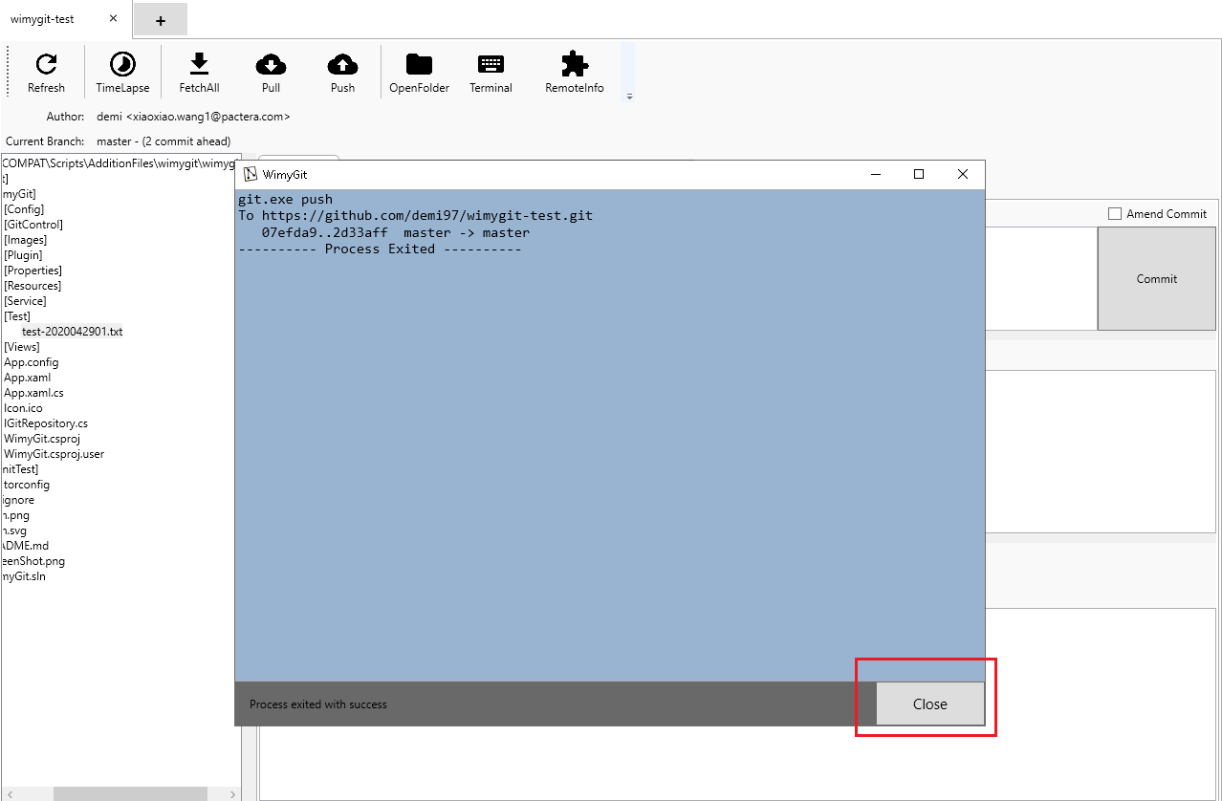

1. Click “+” button to open a new tab.

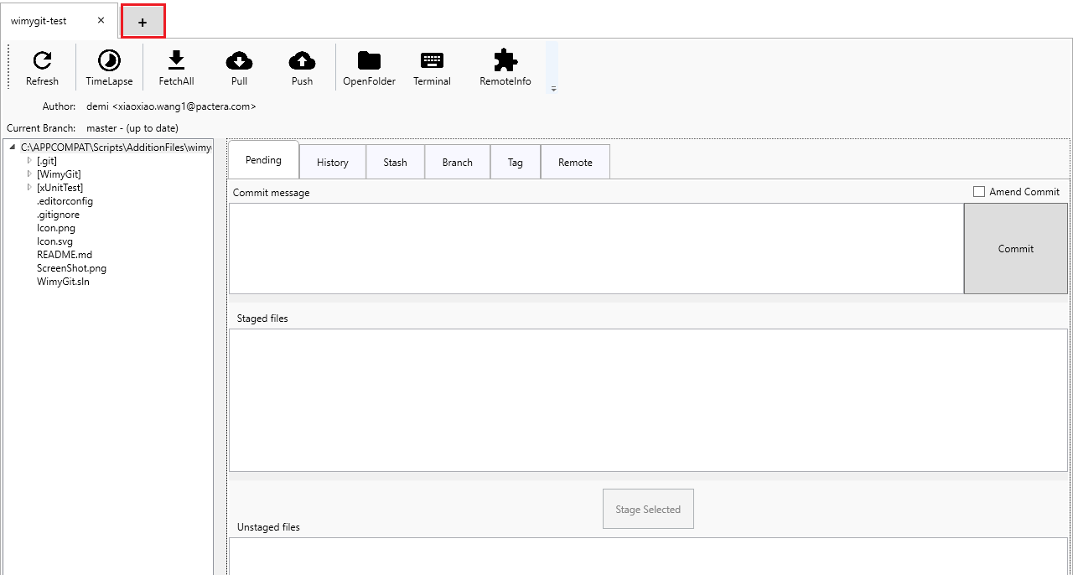

1. Input the “%APP_CLIENT_SCRIPTSDIR%\AdditionFiles\wimygit\wimygit-1” link to input box.
2. Press “OK” button.



1. Click “Pull” button.

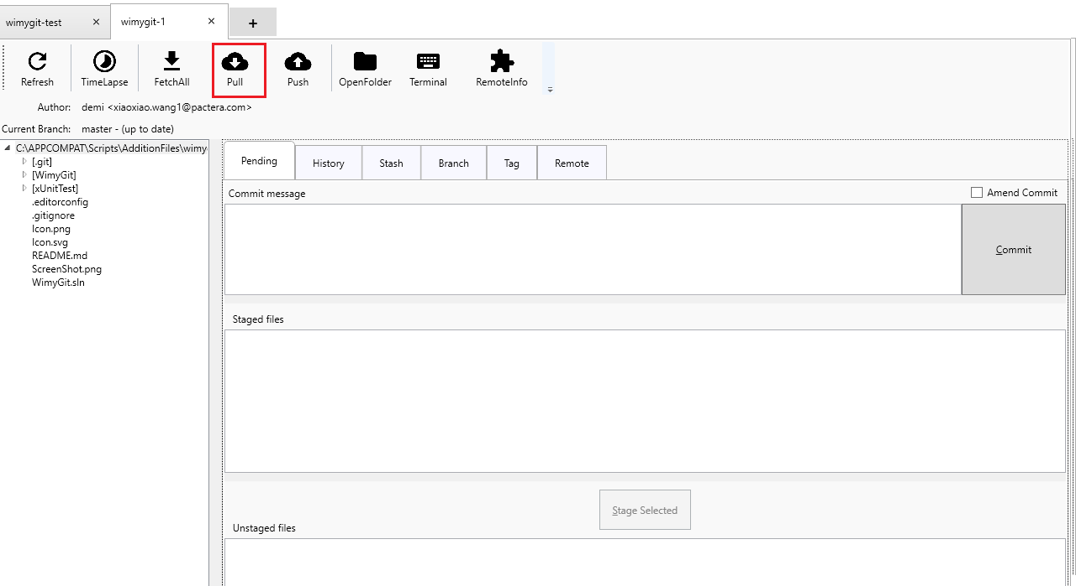

1. **Verify**: There is a “Process exited with success” stentence in the window (The new content has been pulled to local workspace successfully).

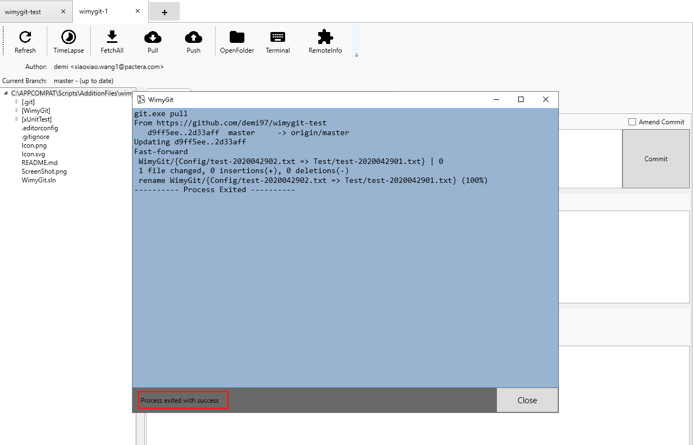

1. Click “Close” button to close the window.

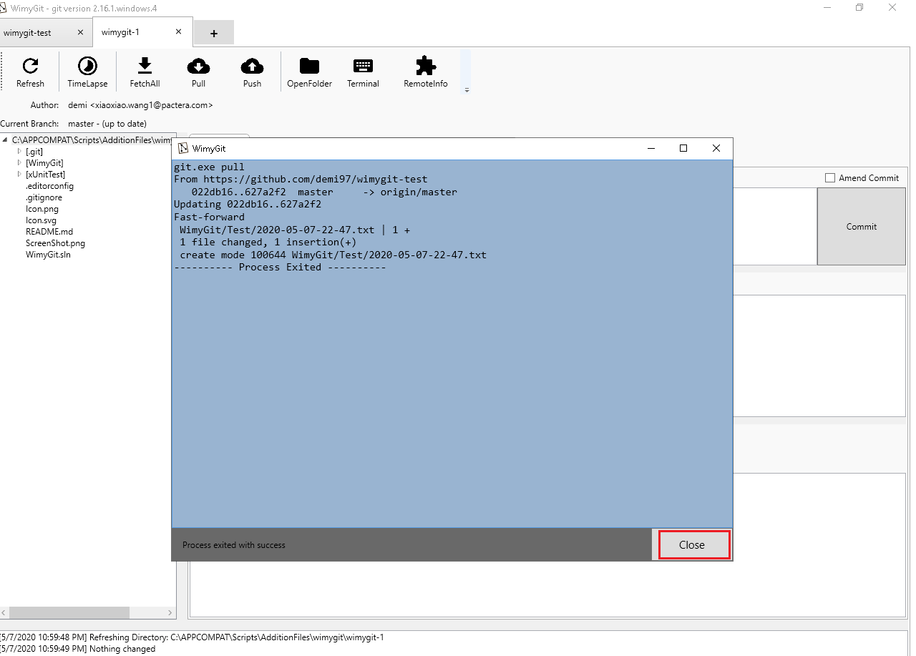

1. Click “+” button to open a new tab.

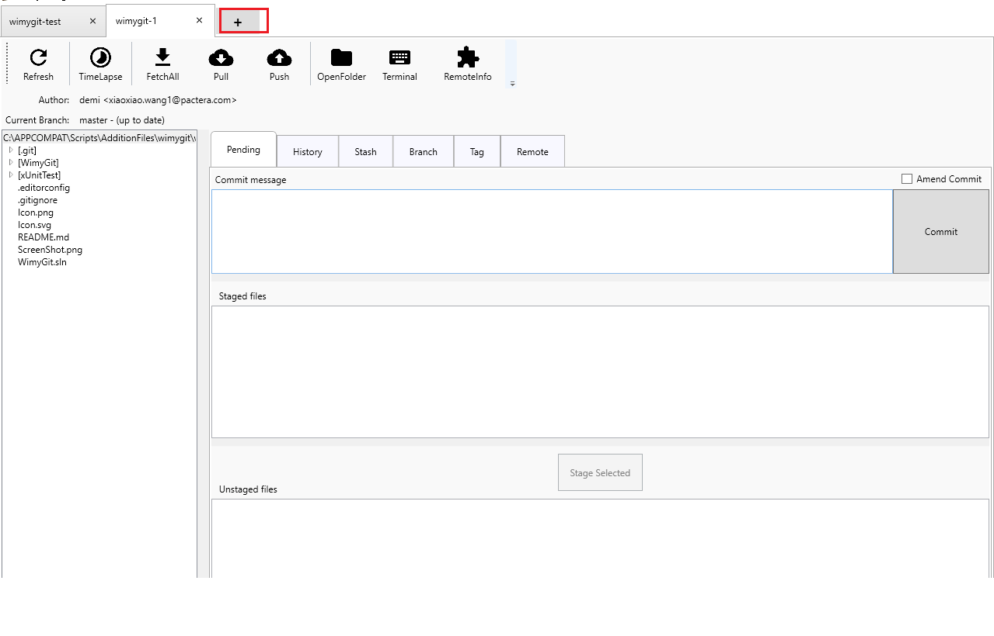

1. Input the ““%APP_CLIENT_SCRIPTSDIR%\AdditionFiles\wimygit\wimygit-2” link to input box.



1. Press “OK” button.



1. Click “FetchAll” button.

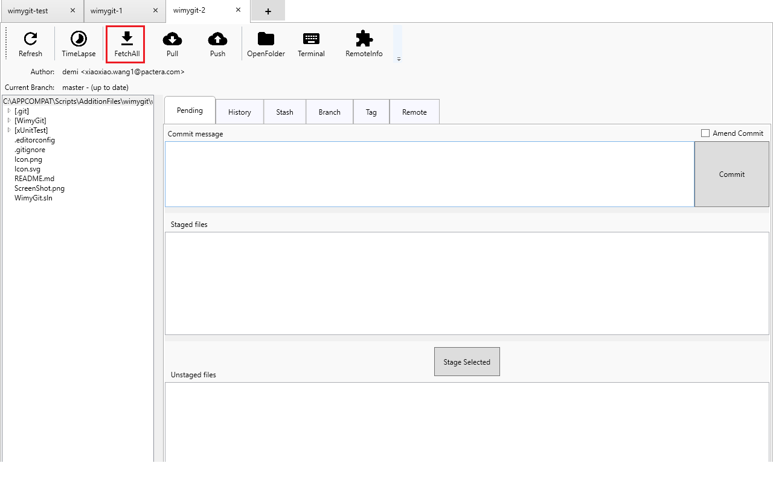

1. **Verify**: There is a “Process exited with success” stentence in the window(The new content has been updated to local repo successfully).

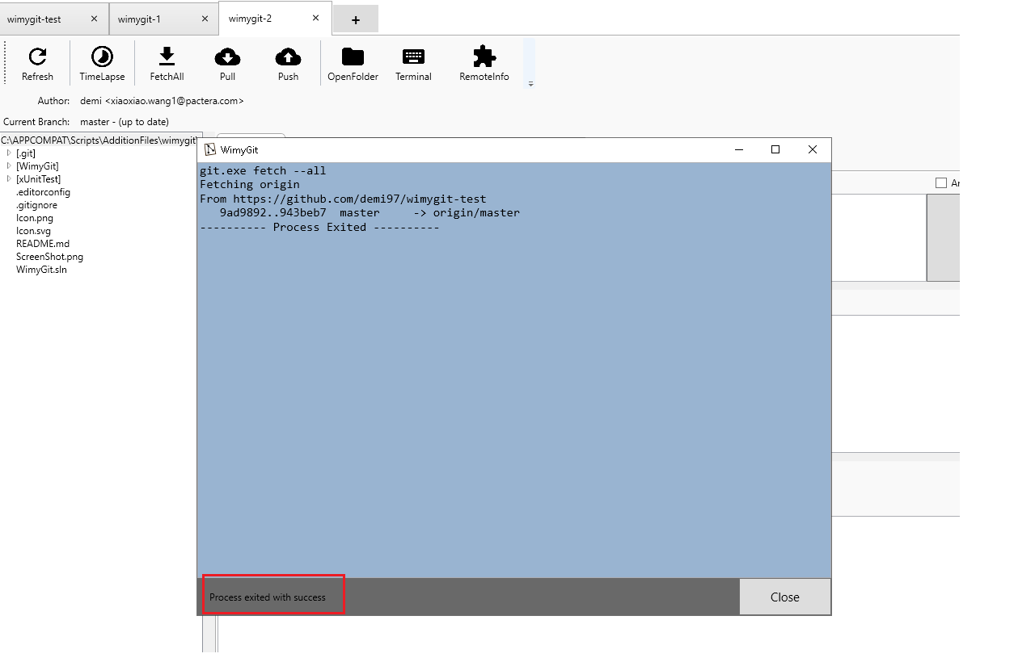

1. Click “Close” buttton to close the window.

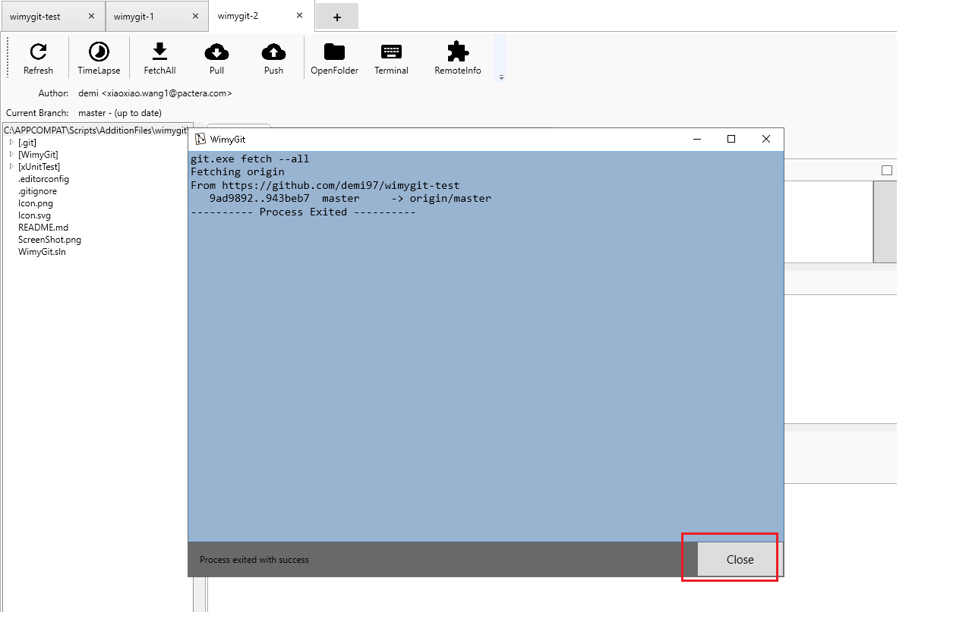

1. Close the wimygit-test tab.

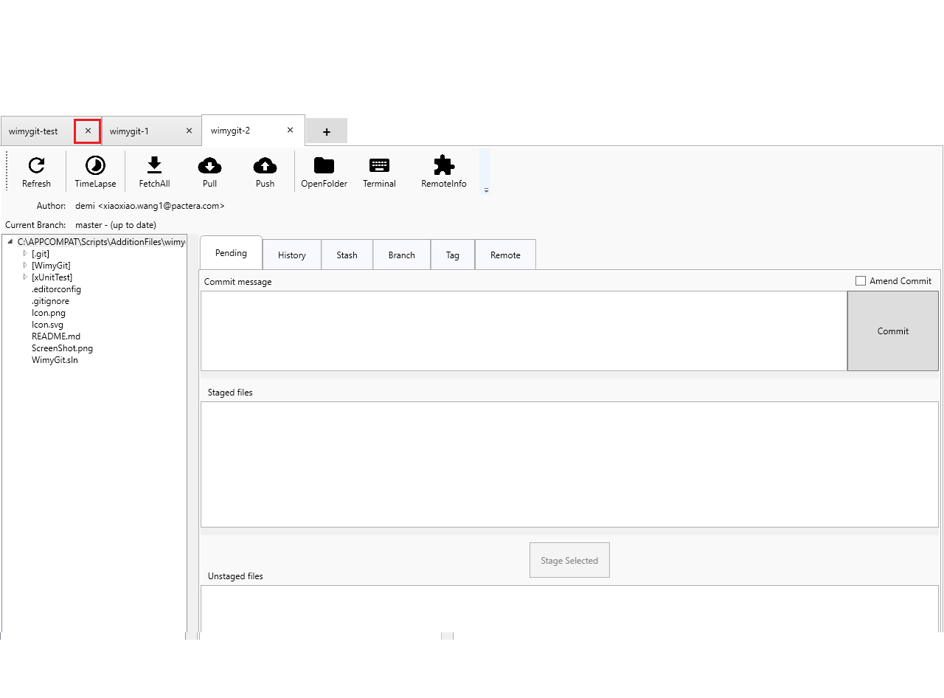

1. Close the wimygit-1 tab.

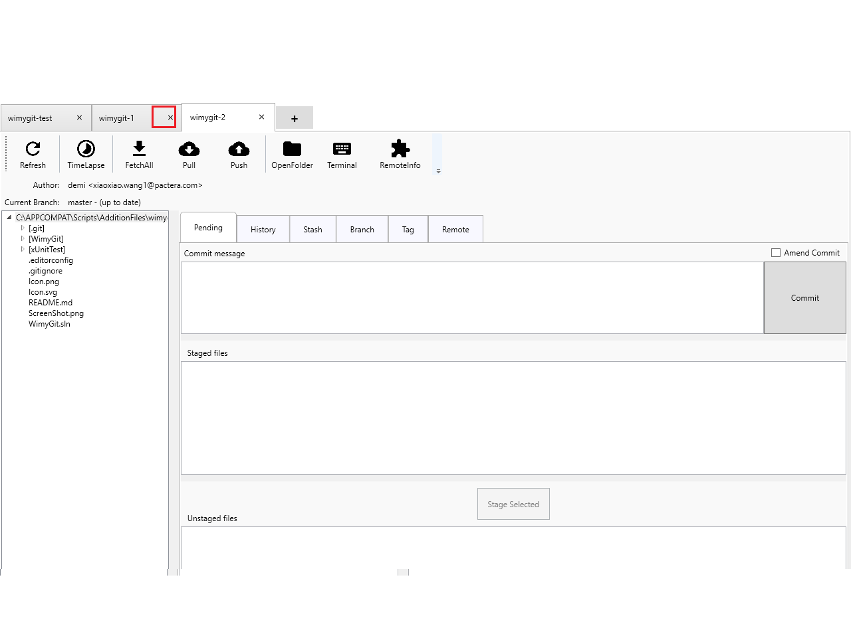

1. Close the wimygit-2 tab.

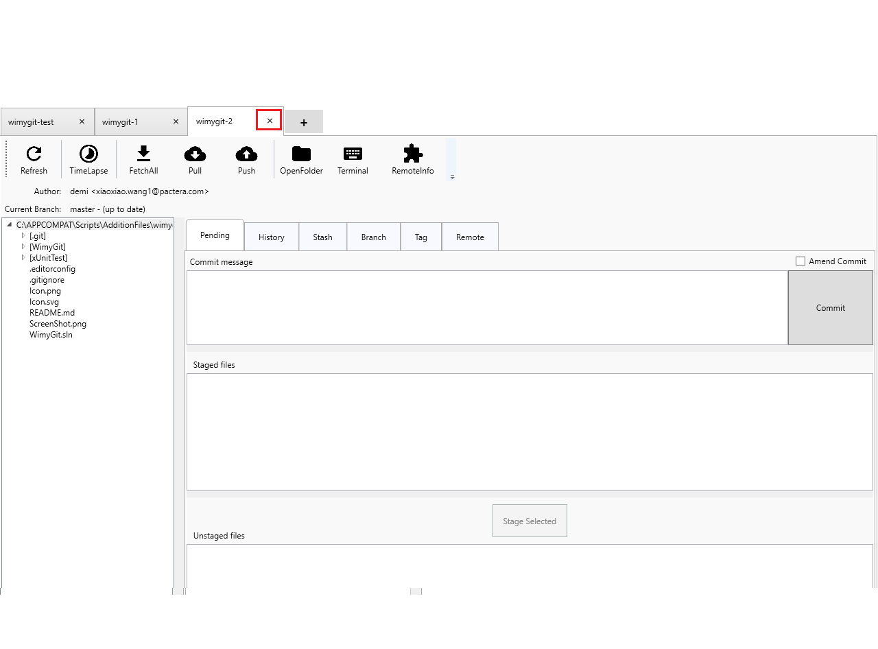

1. Close the app.

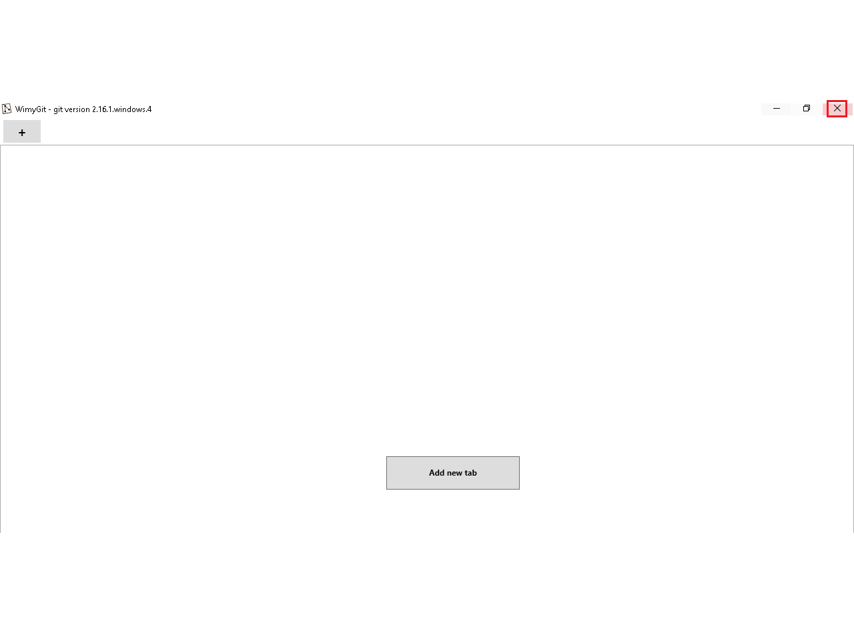

## Scenario 2: Test TimeLapse

**Case ID: APP_3166_002**

**Test Steps:**

1. Launch appliciaton from "%APP_CLIENT_ROOT%\application\WimyGit\WimyGit.exe".
2. Input the “%APP_CLIENT_SCRIPTSDIR%\AdditionFiles\wimygit\wimygit-test” link to input box”.
3. Press “OK” button.



1. Double click the “[WimyGit]” tree.

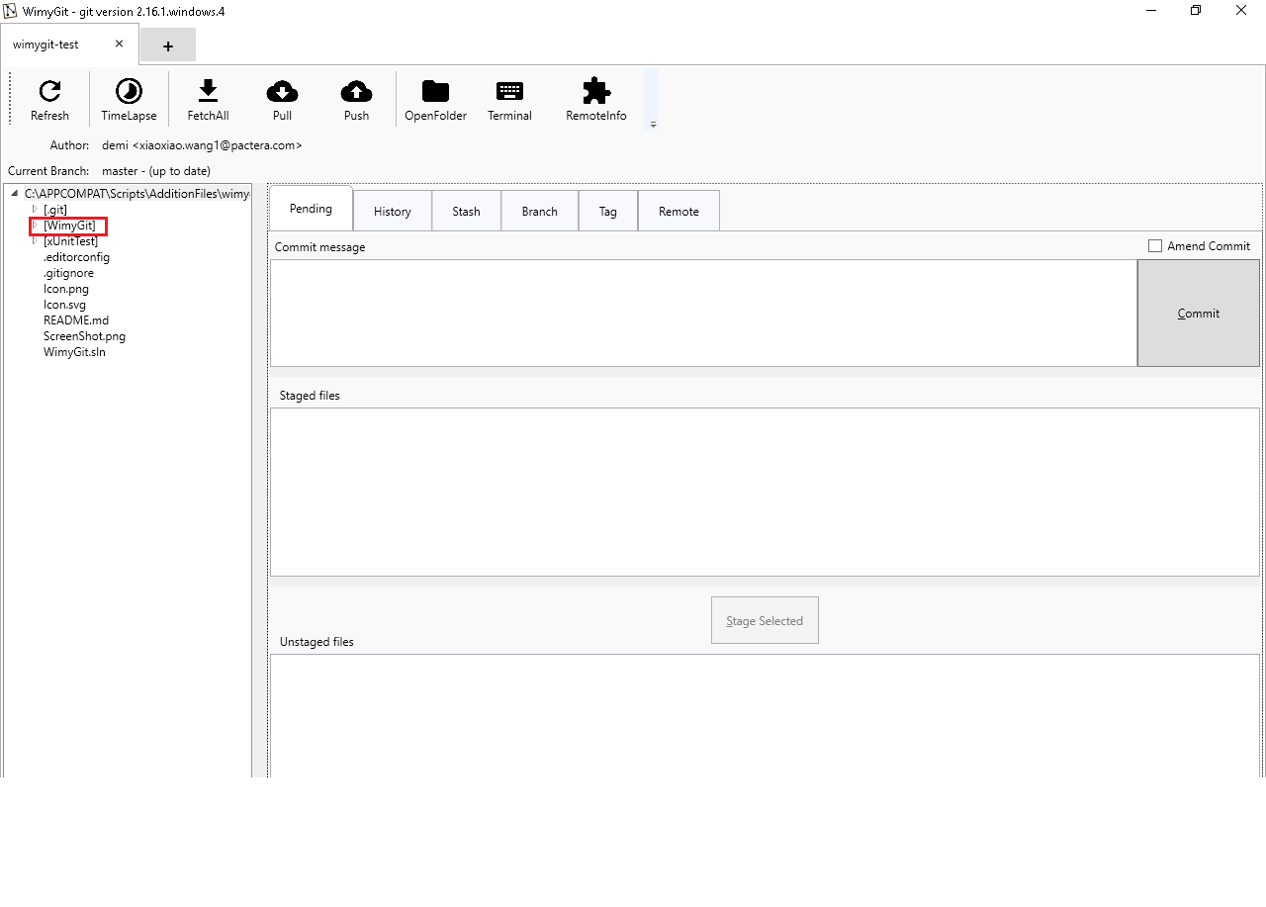

1. Double click the “[Config]” children tree.

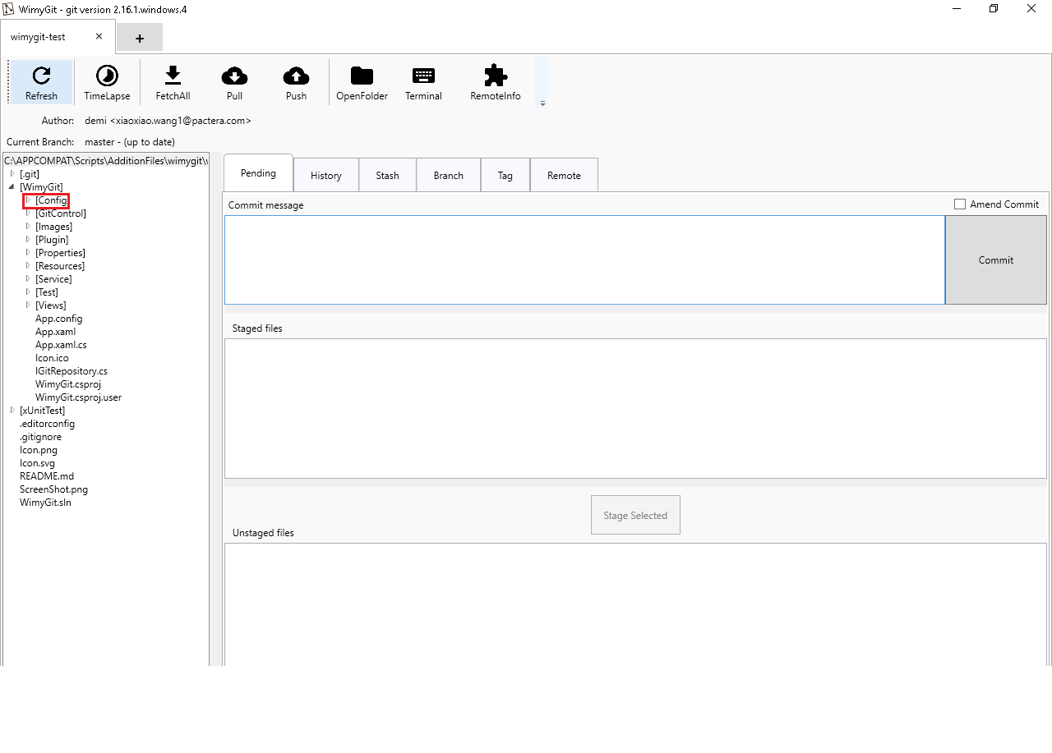

1. Select Model.cs class in Config folder.

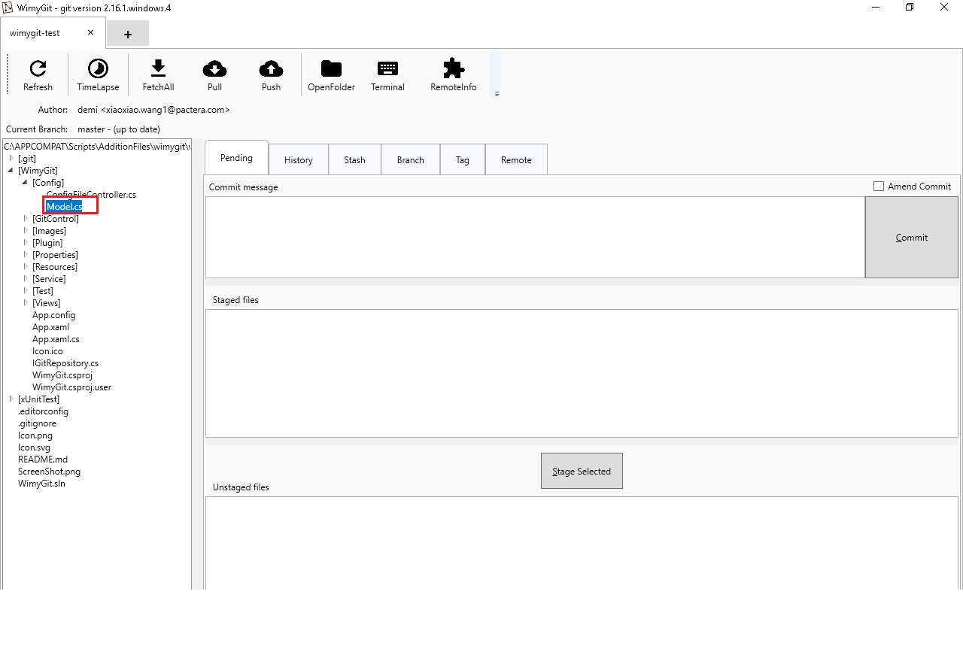

1. Click “TimeLapse” button.

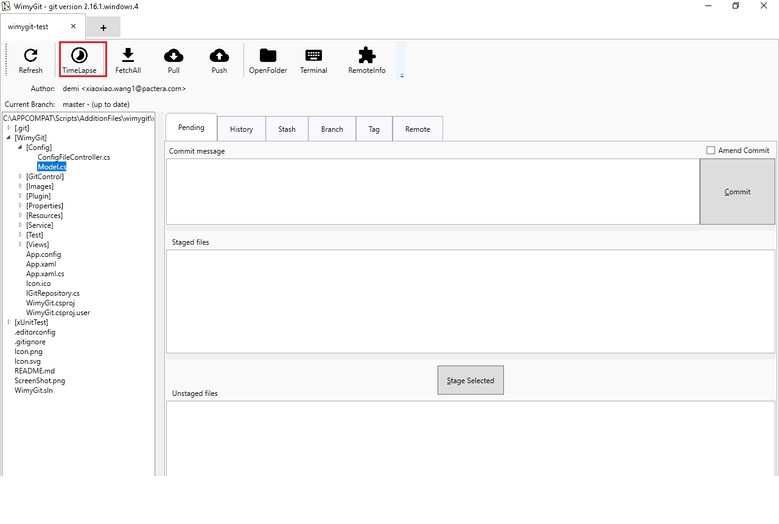

1. **Verify**: The path you open is “%APP_CLIENT_SCRIPTSDIR%/AdditionFiles/wimygit/wimygit-test/WimyGit/Config/Model.cs”.

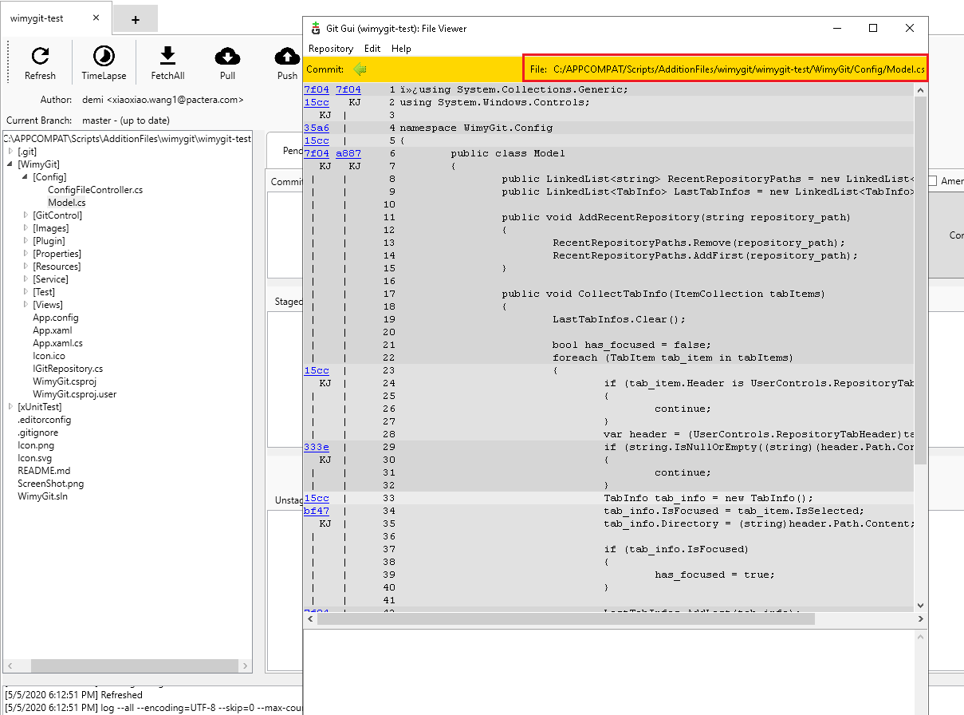

1. Close the window.

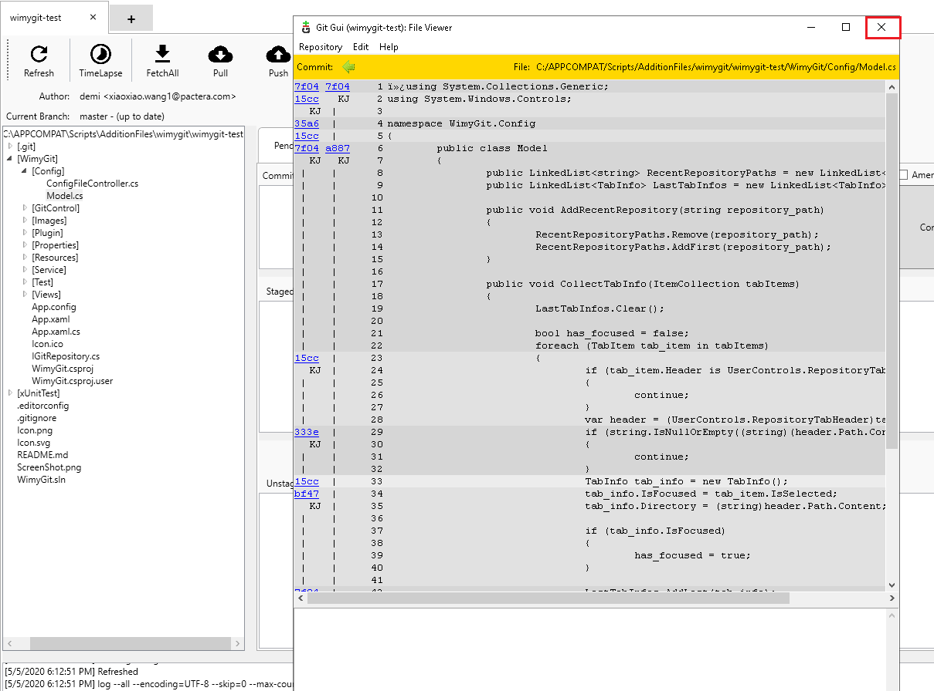

1. Close the wimygit-test tab.

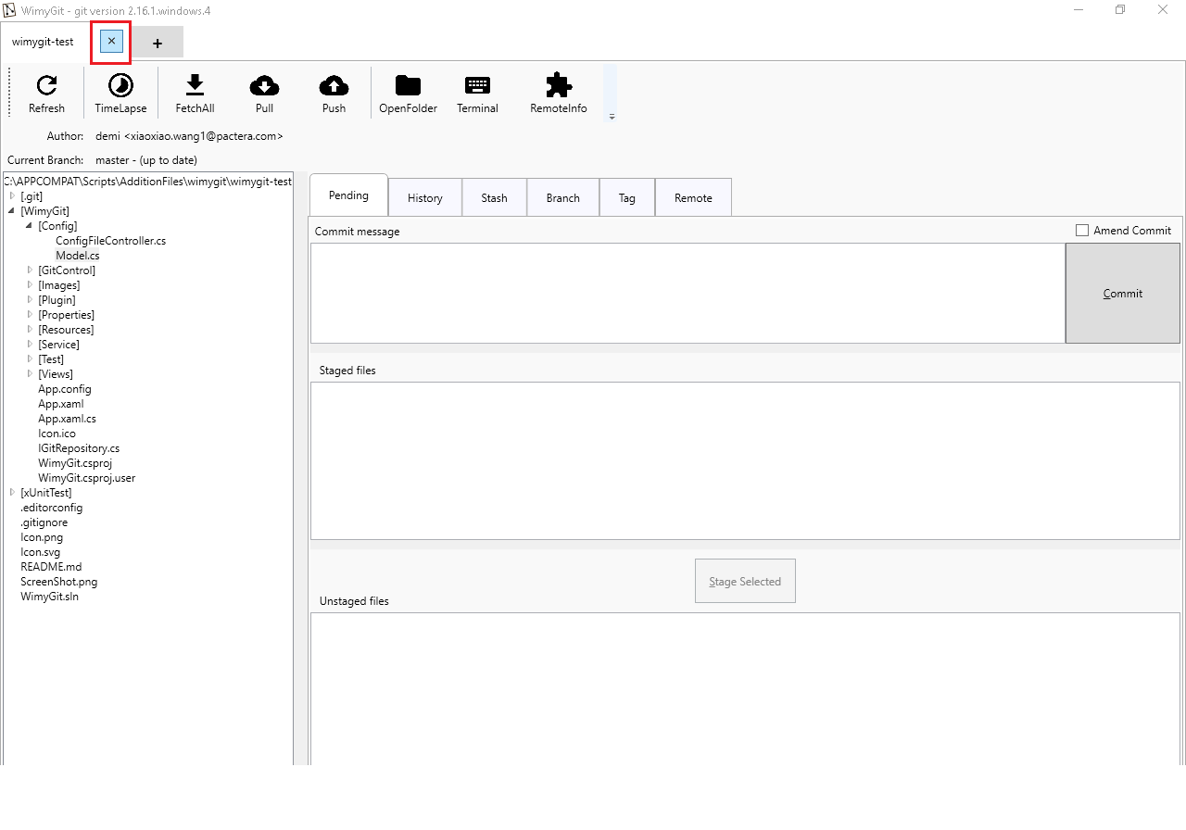

1. Close the app.

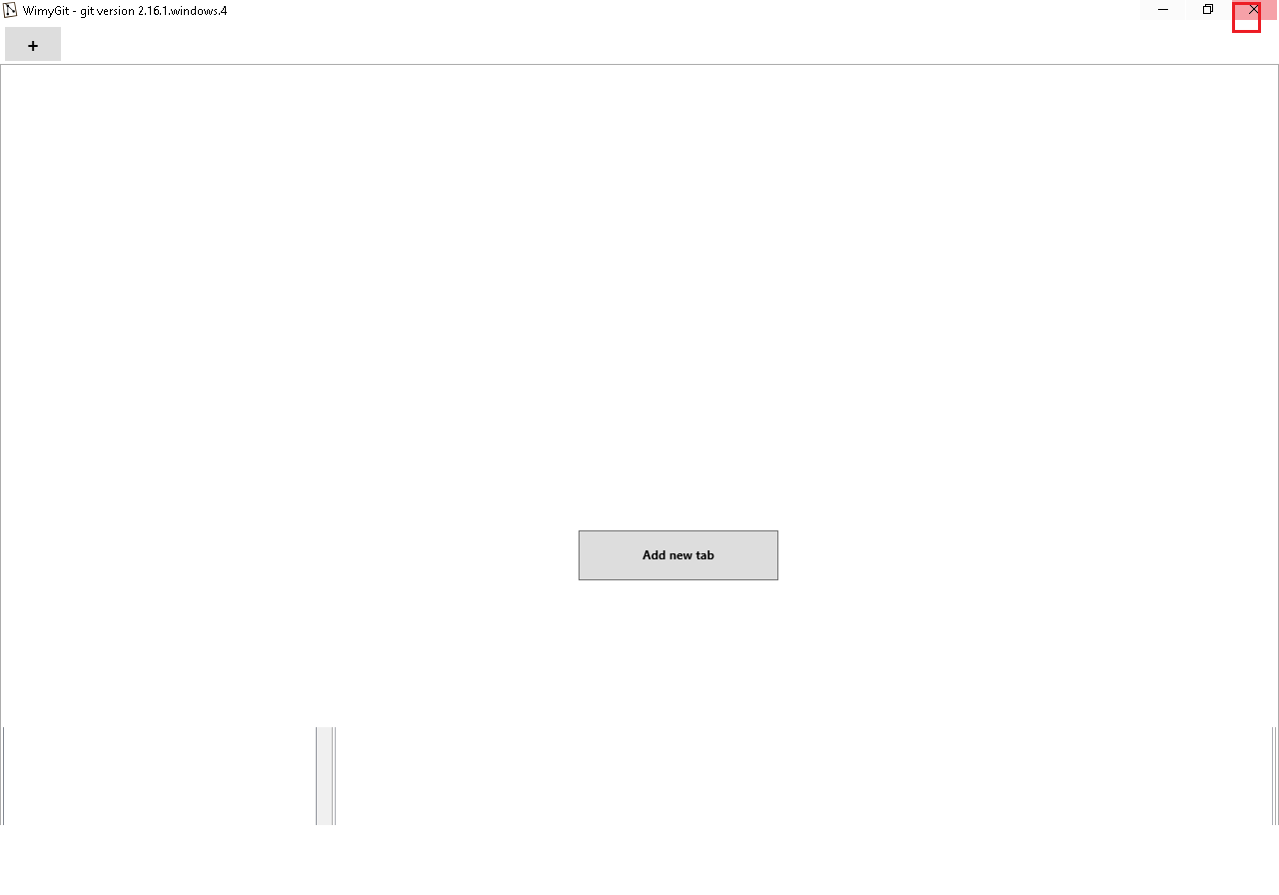

## Scenario 3: Test OpenFolder/Terminal/RemoteInfo

**Case ID: APP_3166_003**

**Test Steps:**

1. Launch appliciaton from "%APP_CLIENT_ROOT%\application\WimyGit\WimyGit.exe".
2. Input the “%APP_CLIENT_SCRIPTSDIR%\AdditionFiles\wimygit\wimygit-test” link to input box.
3. Press “OK” button.



1. Click “OpenFolder” button.

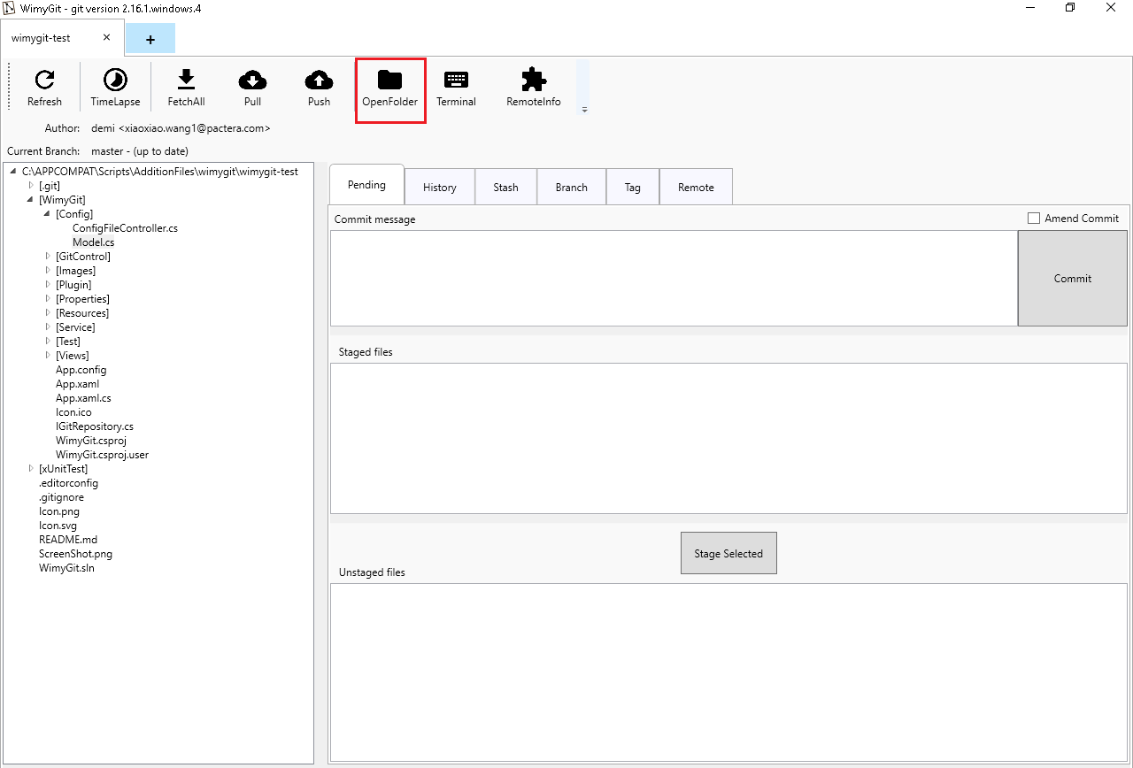

1. Select the folder address.

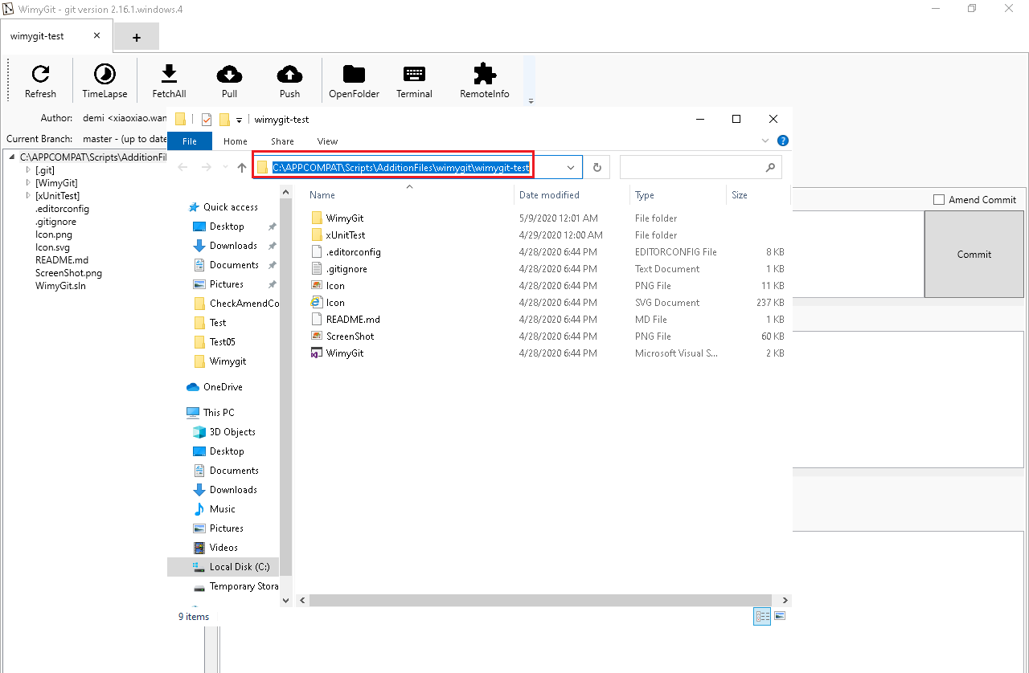

1. **Verify**: The path of Openfolder is same as the app path.They are all “%APP_CLIENT_SCRIPTSDIR%\AdditionFiles\wimygit\wimygit-test”.

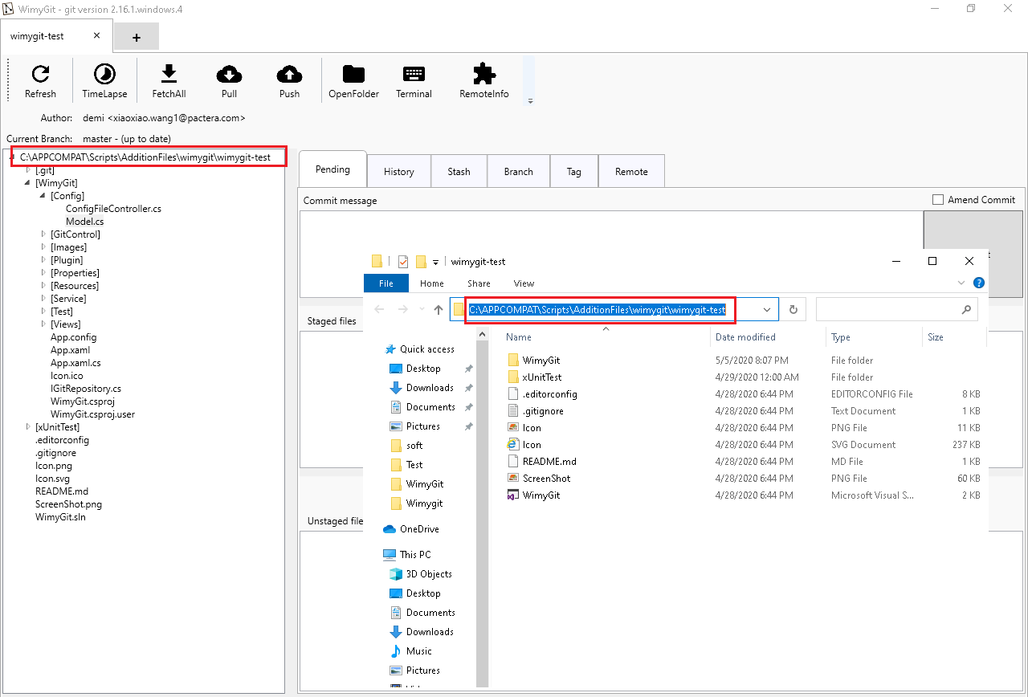

1. Click the “X” button to close the folder window.

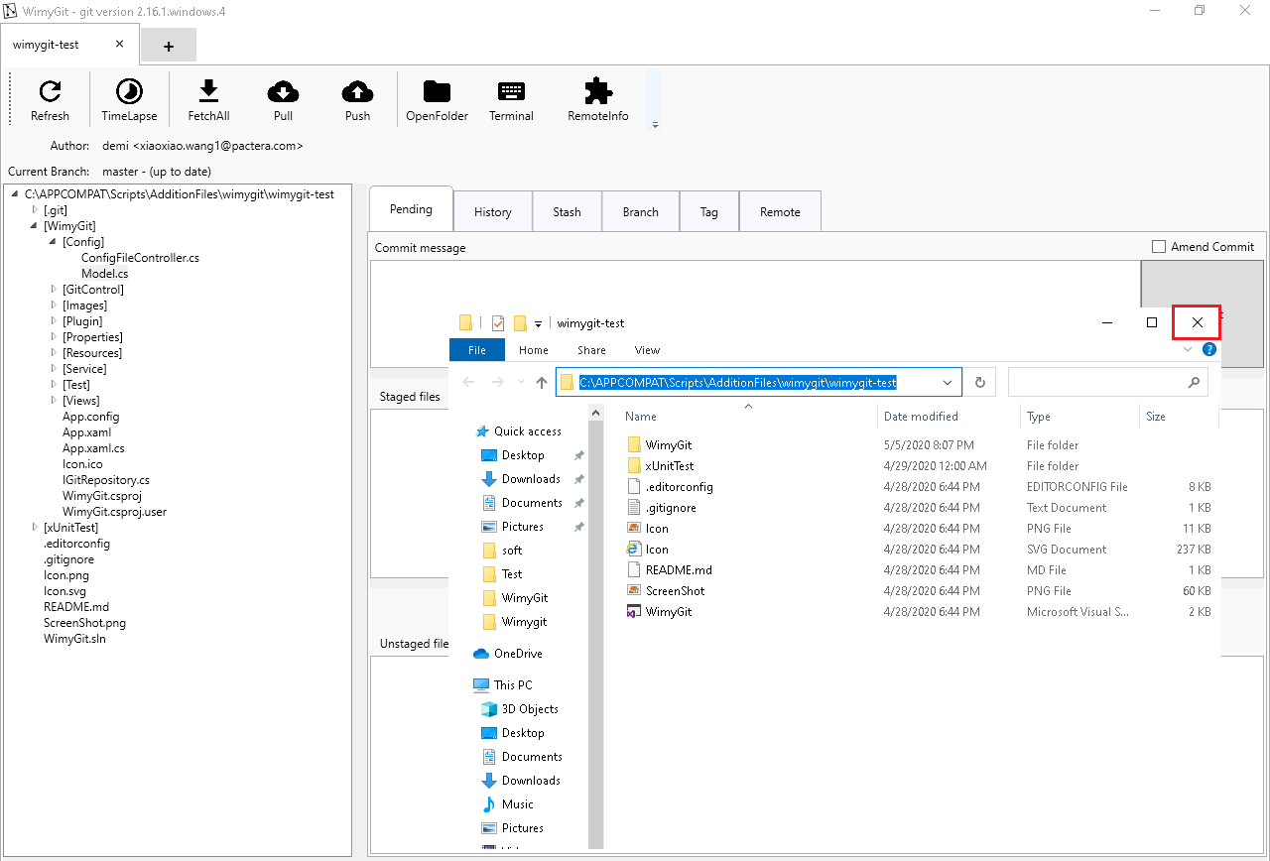

1. Click “Terminal” button.

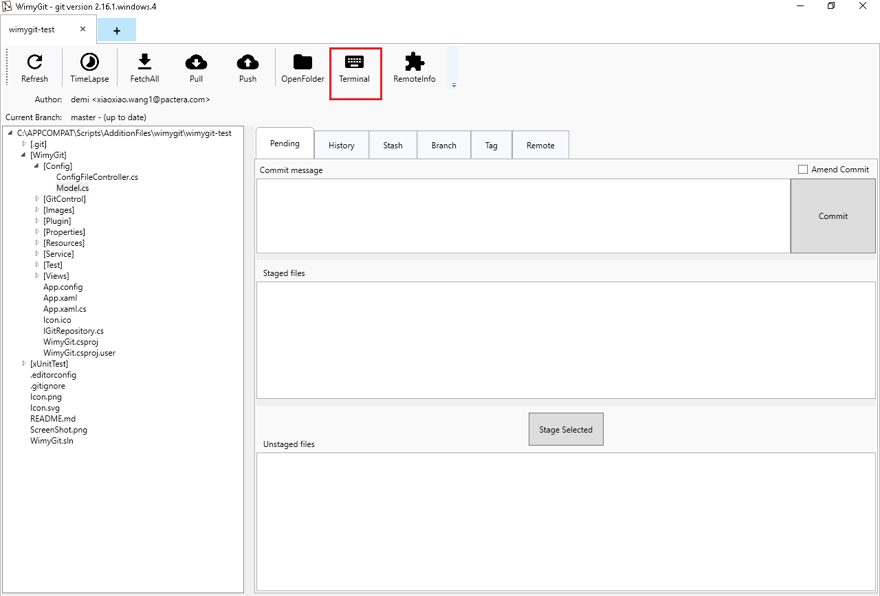

1. **Verify**: The path of Terminal is same as the app path.They are all “%APP_CLIENT_SCRIPTSDIR%\AdditionFiles\wimygit\wimygit-test”.

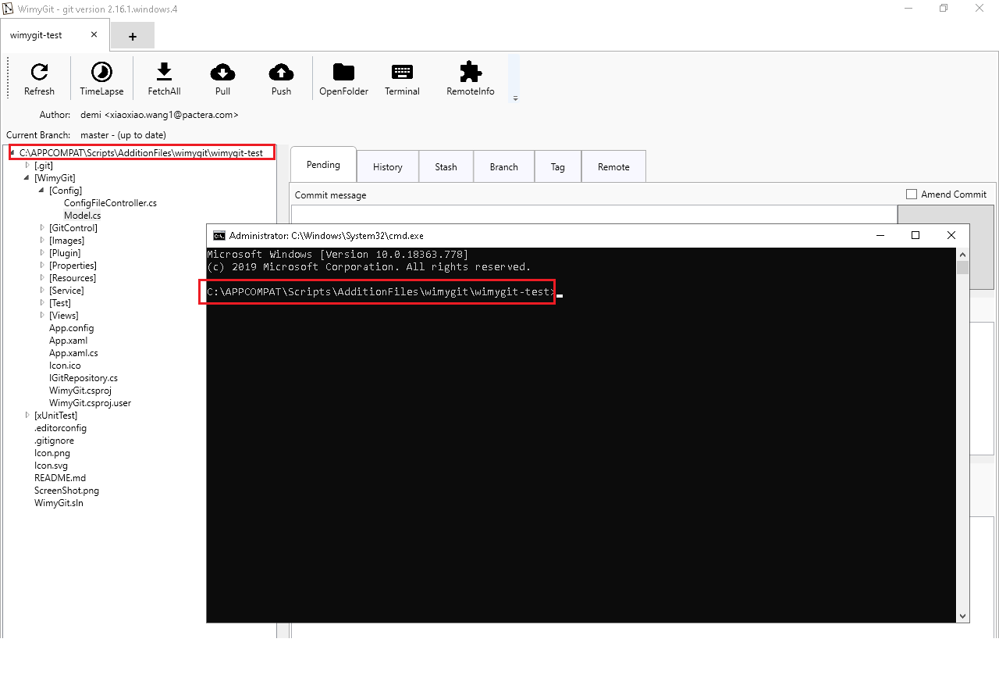

1. Click the “X” button to close the command window.

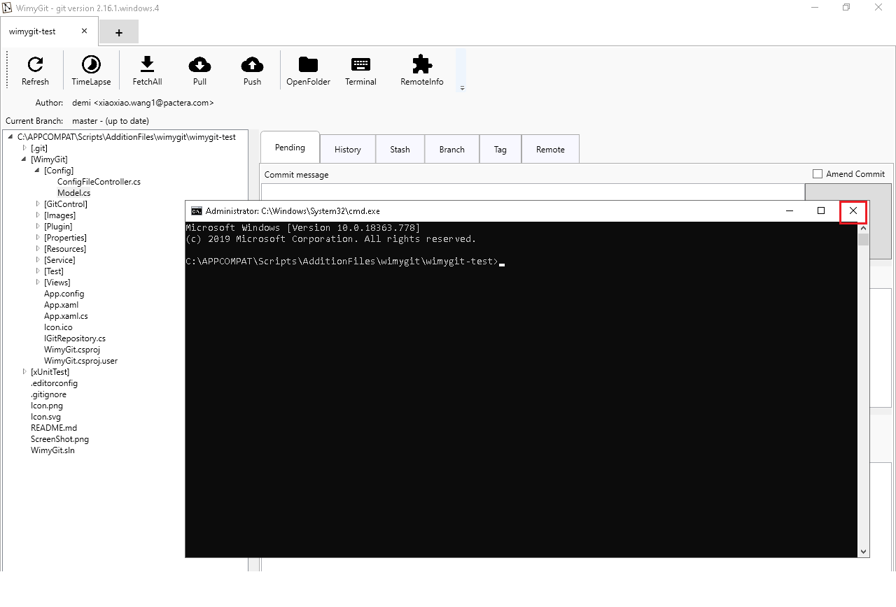

1. Click “RemoteInfo” button.

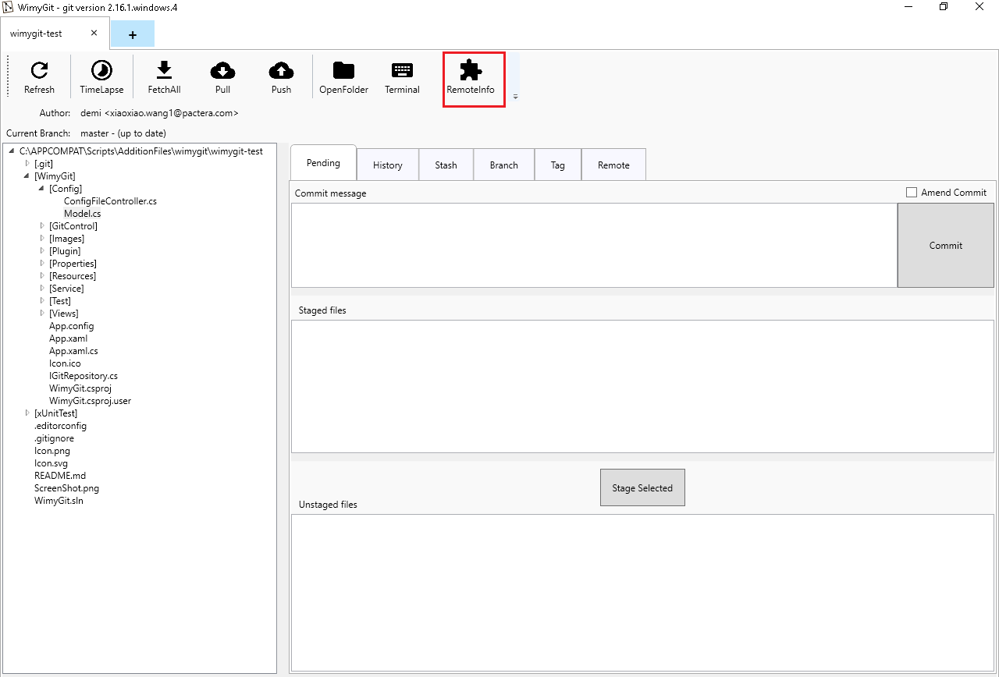

1. **Verify**: There is “Process exited with success” sentence in the window.

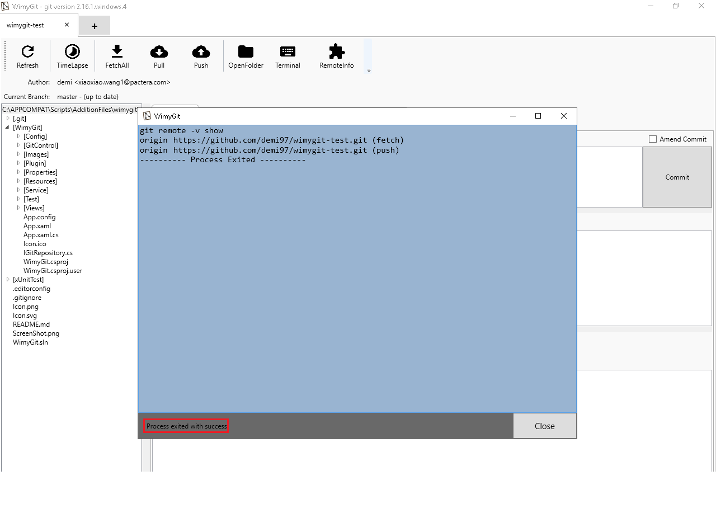

1. Click “Close” button to close the RemoteInfo window.

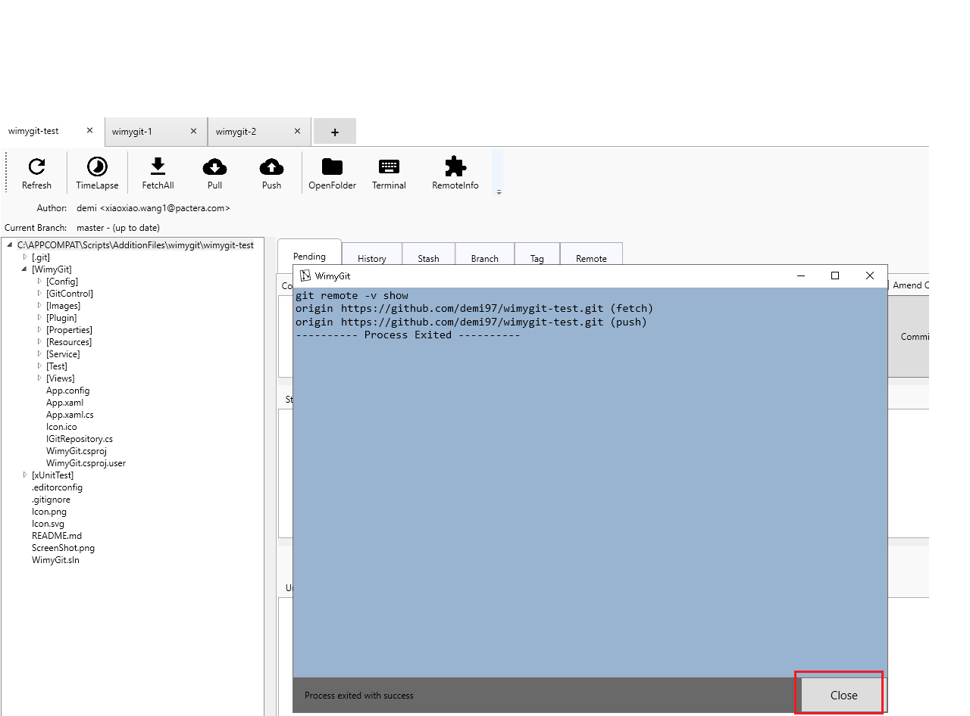

1. Close the wimygit-test tab.

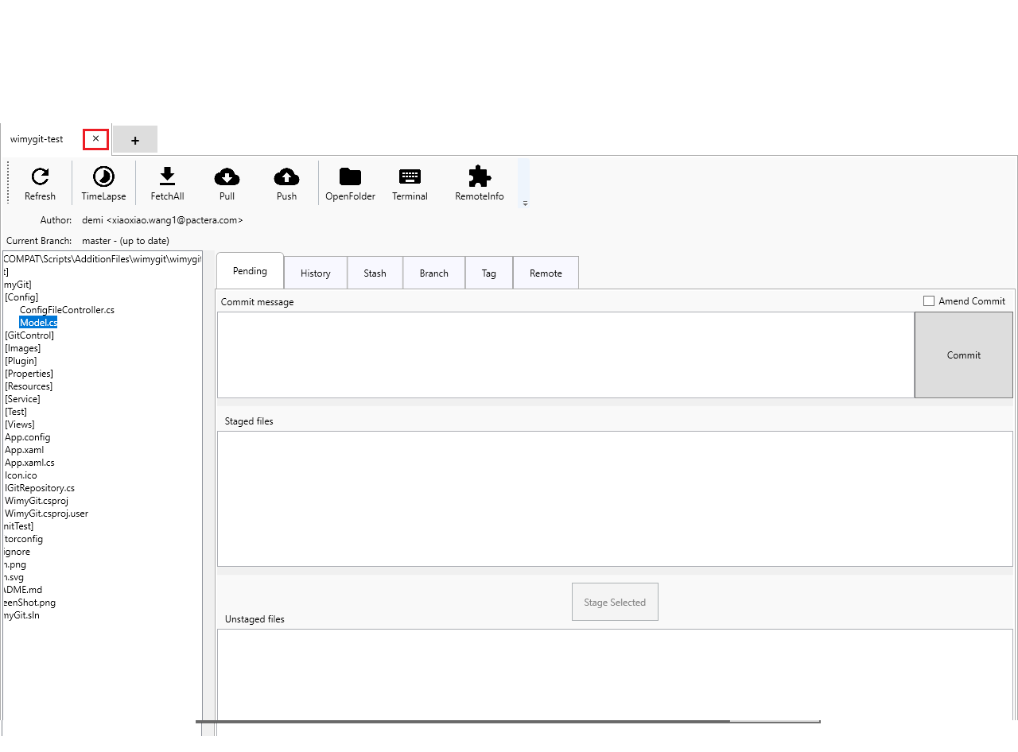

1. Close the app.



## Scenario 4: Test Stash

**Case ID: APP_3166_004**

**Test Steps:**

1. Launch appliciaton from "%APP_CLIENT_ROOT%\WimyGit\WimyGit.exe".
2. Input the “%APP_CLIENT_SCRIPTSDIR%\AdditionFiles\wimygit\wimygit-test” link to input box.



1. Press “OK” button.



1. Click “Stash” button to switch to Stash Tab.

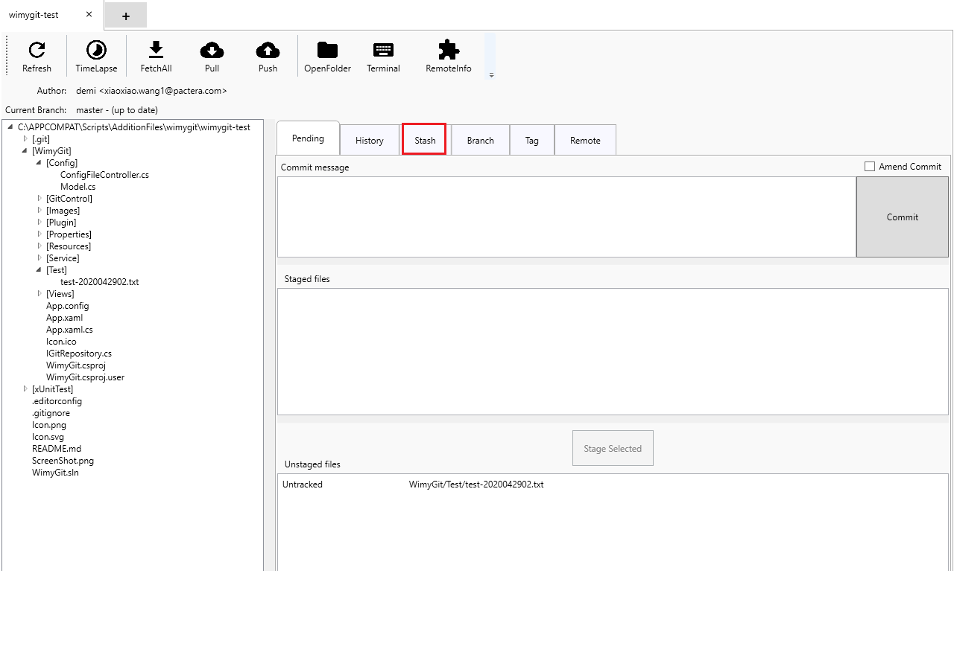

1. Click “Push All Changes” button.

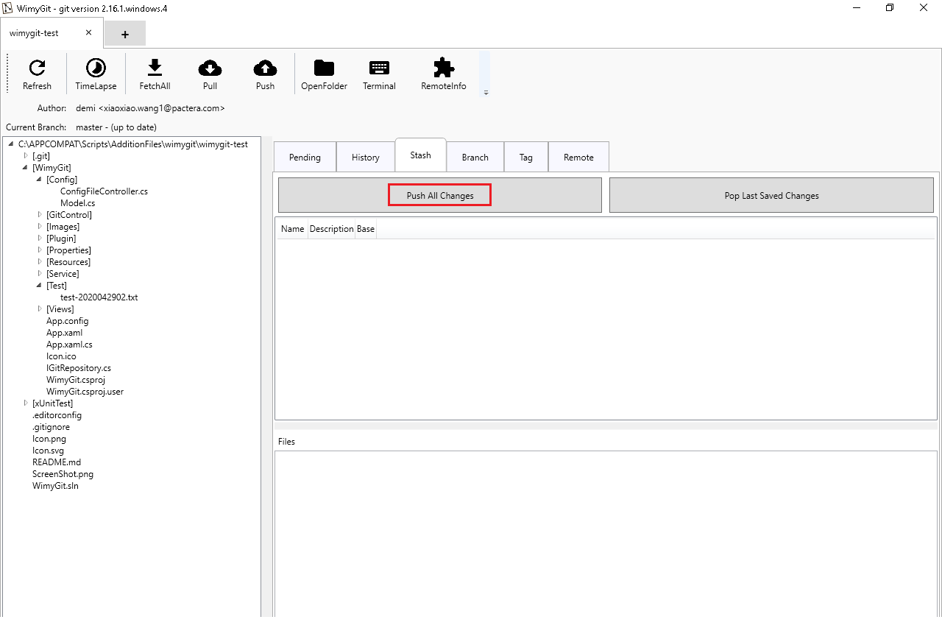

1. Input “create” stash message in QuestionWindow.

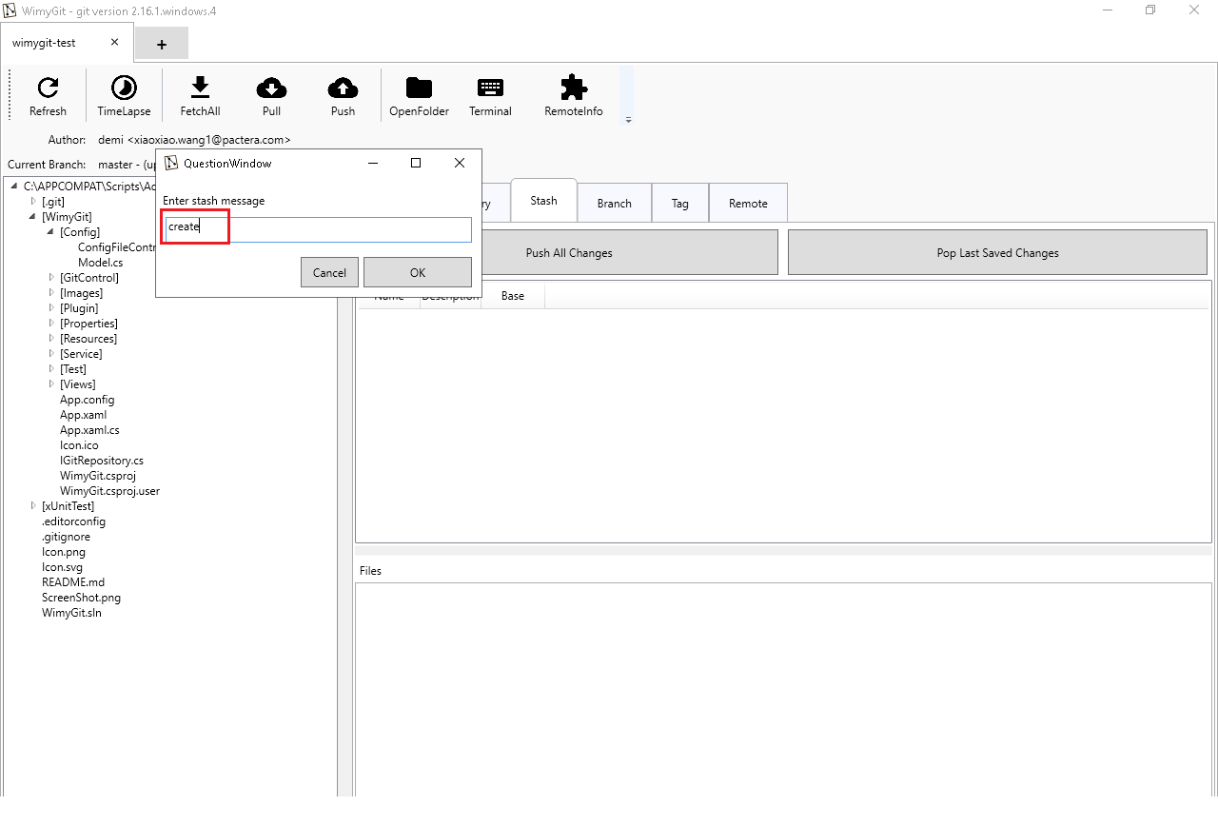

1. Click “OK” button.

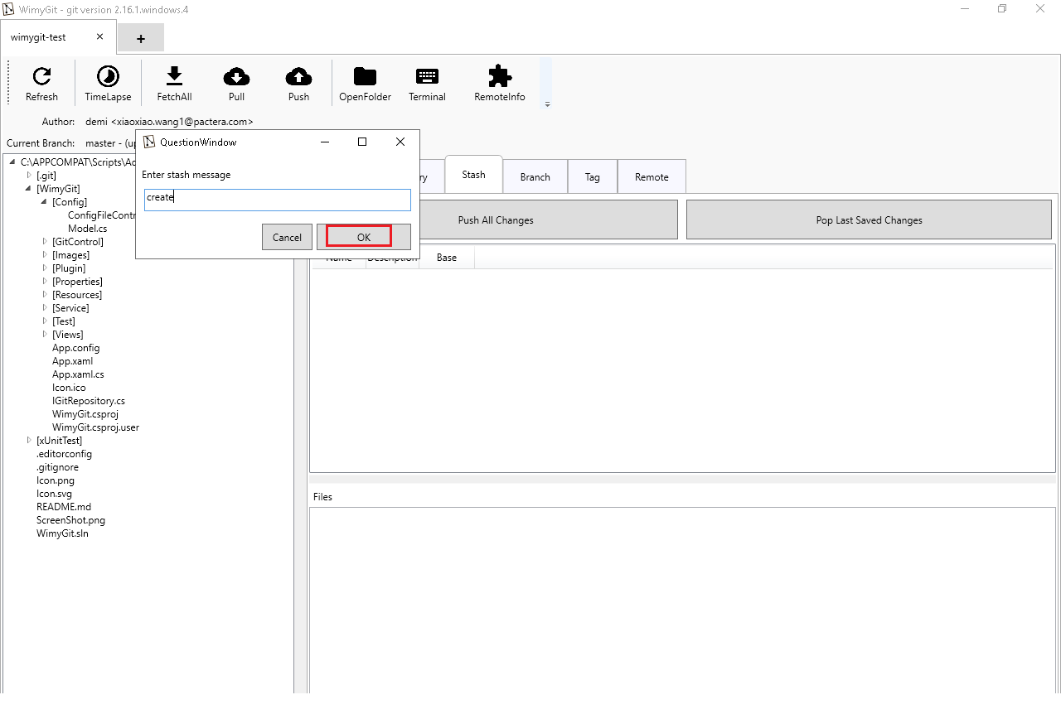

1. **Verify**: There is a “Process exited with success” stentence in the window (The file in unstaged f iles has been stashed successfully).

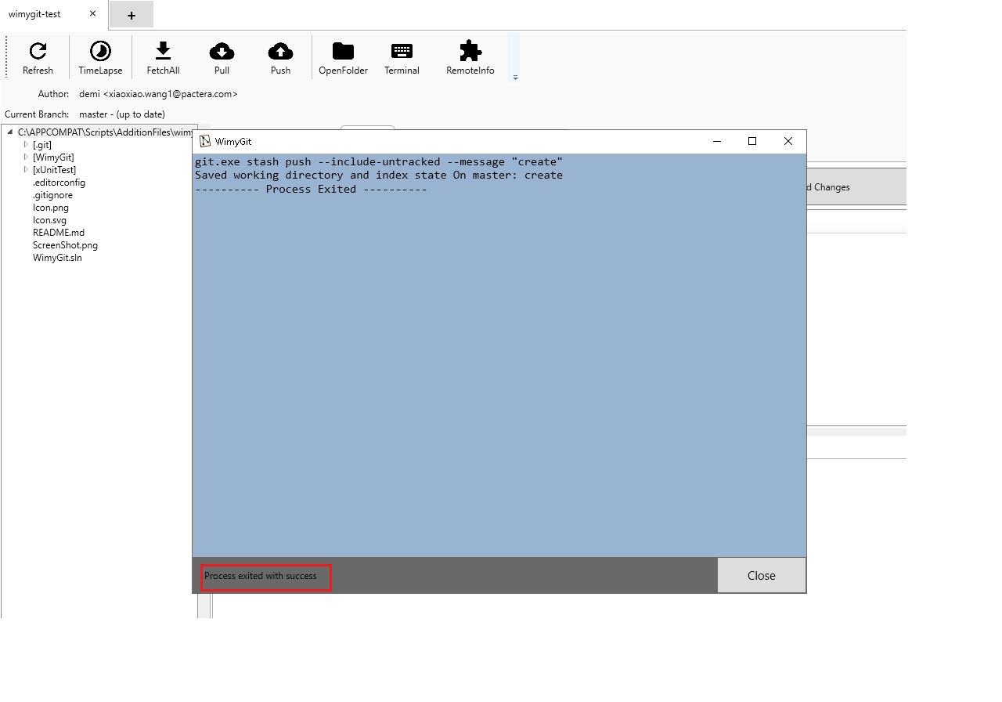

1. Click “Close” button to close the window.

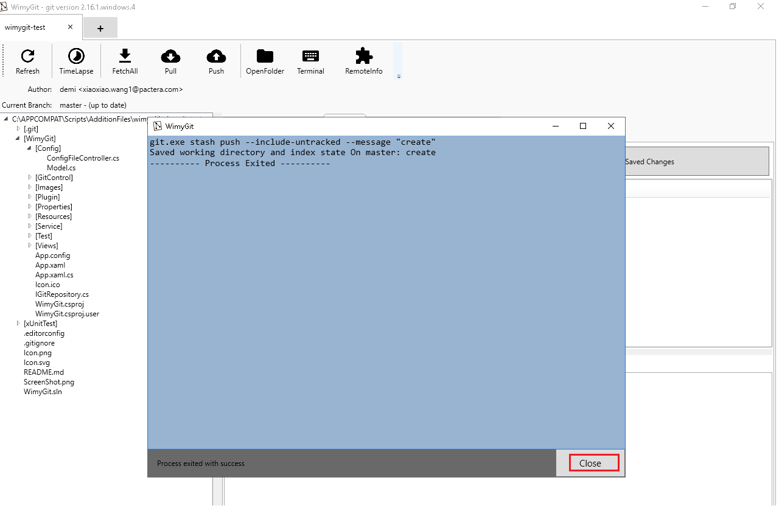

1. Click “Pop Last Saved Changes” button.

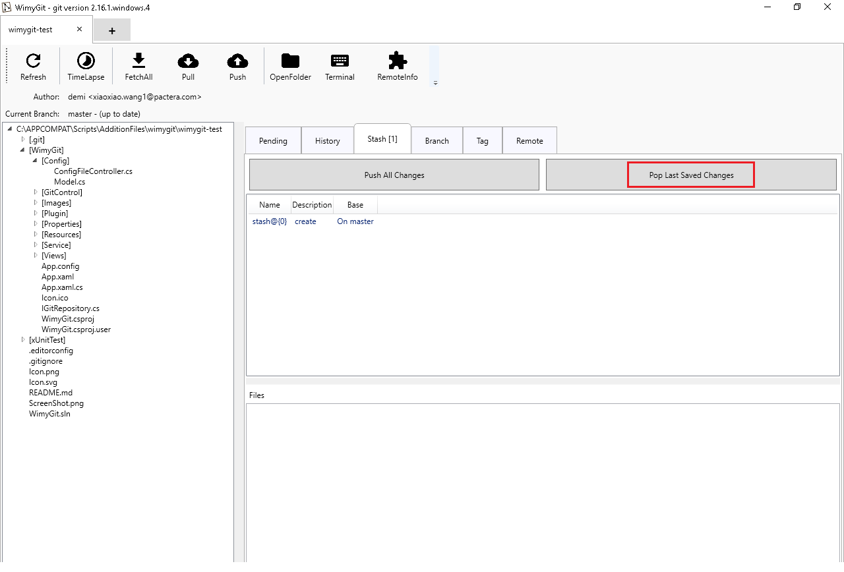

1. **Verify**: There is a “Process exited with success” stentence in the window (The file poped out from stashed area successfully).

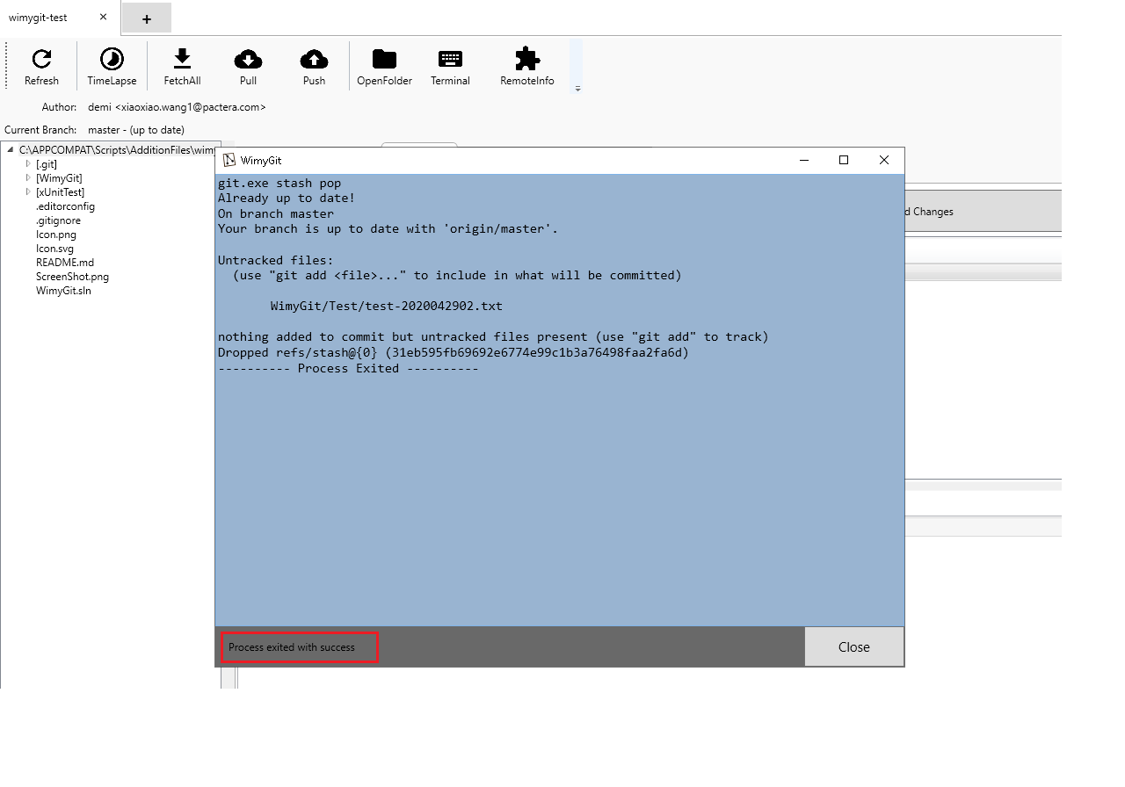

1. Click “Close” button to close the window.

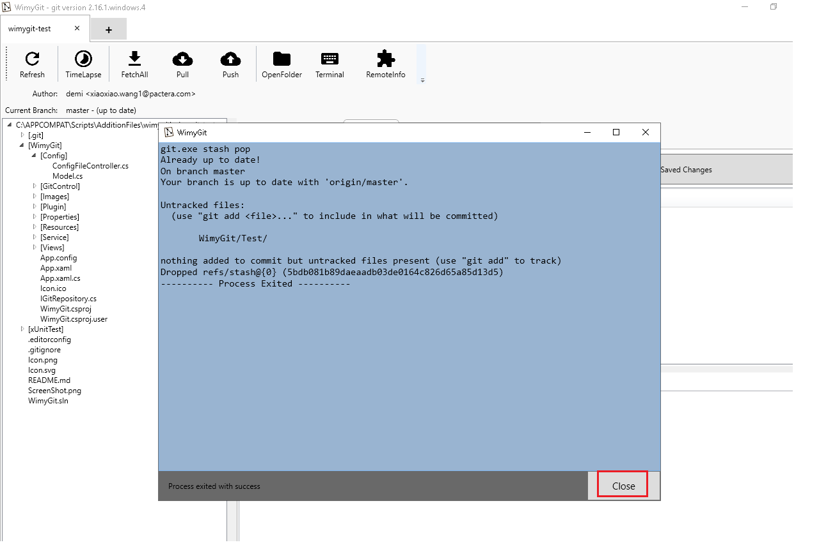

1. Close the “wimygit-test” tab.



1. Close the app.



## Scenario 5: Test Amend Commit

**Case ID: APP_3166_005**

**Test Steps:**

1. Launch appliciaton from "%APP_CLIENT_ROOT%\WimyGit\WimyGit.exe".
2. Input the “%APP_CLIENT_SCRIPTSDIR%\AdditionFiles\wimygit\wimygit-test” link to input box.
3. Press “OK” button.



1. Select the file in unstaged files.

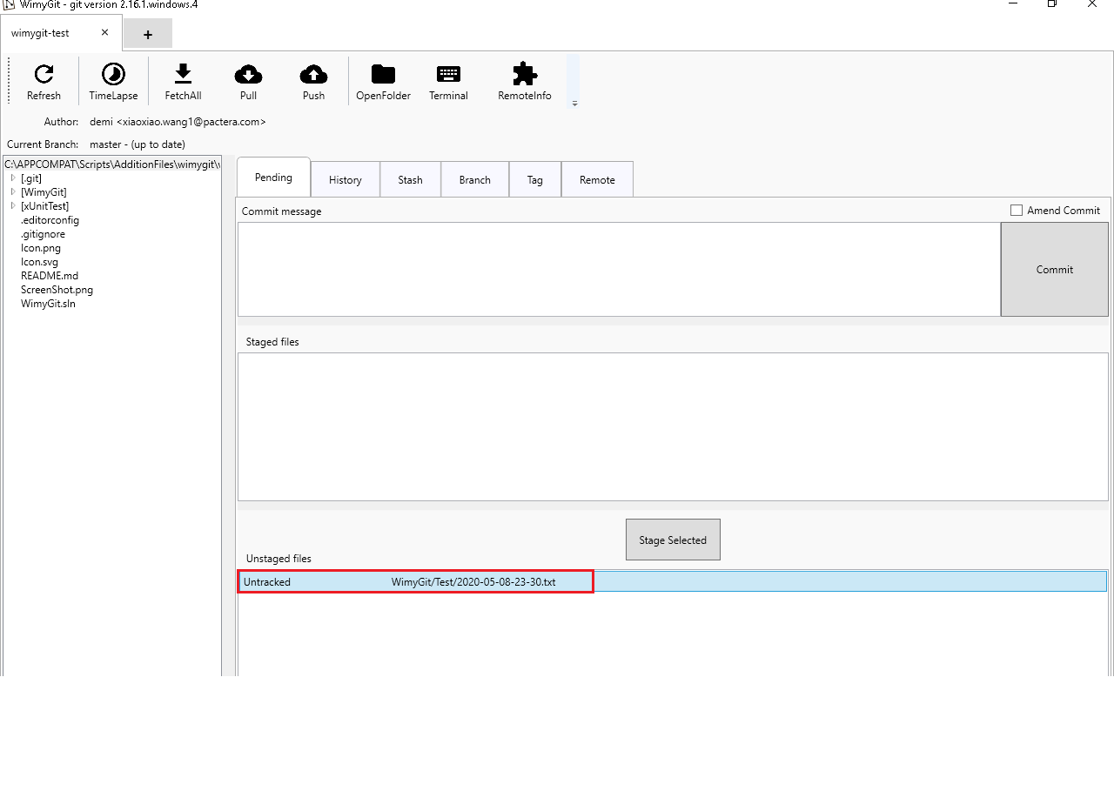

1. Click “Stage Selected” button.

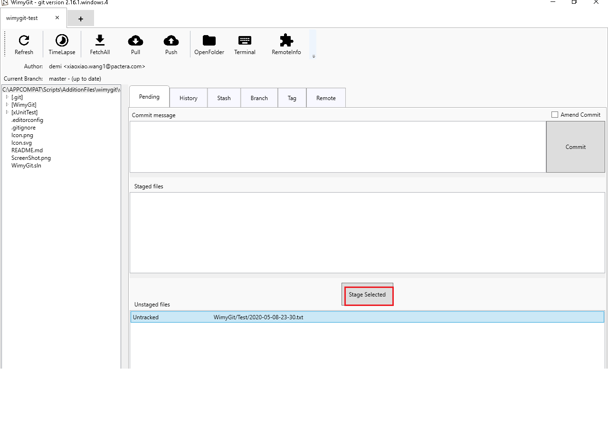

1. Select the “Amend Commit” checkbox.

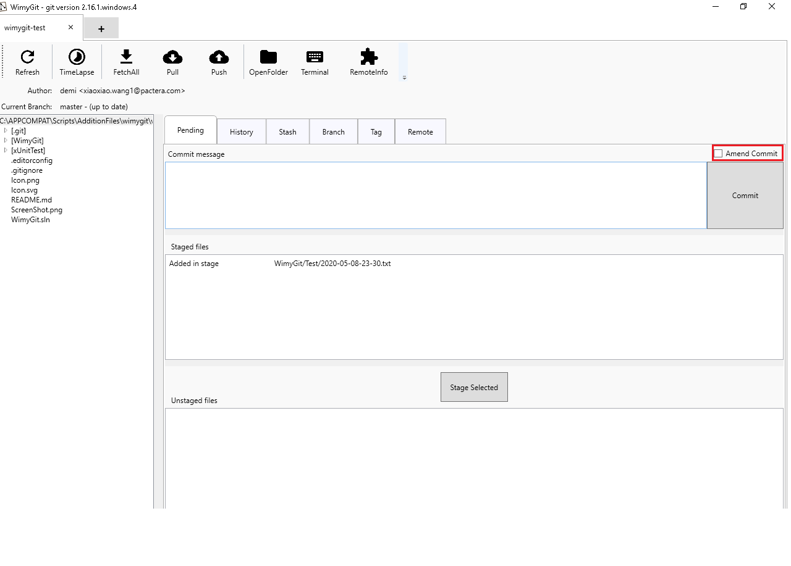

1. Click “No” button in pop-up box.

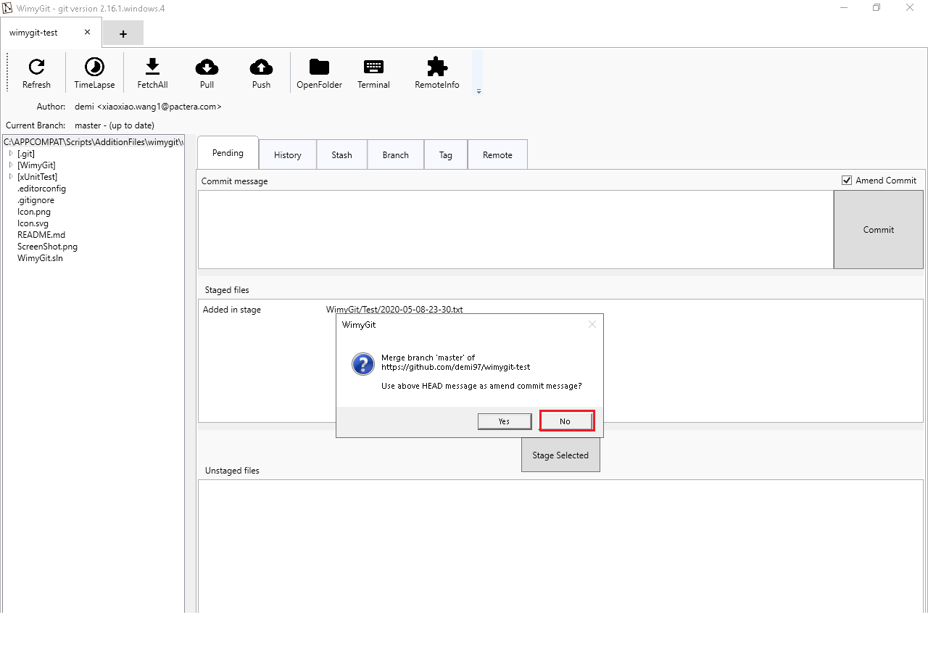

1. Input “Create the second file” message in commit box.

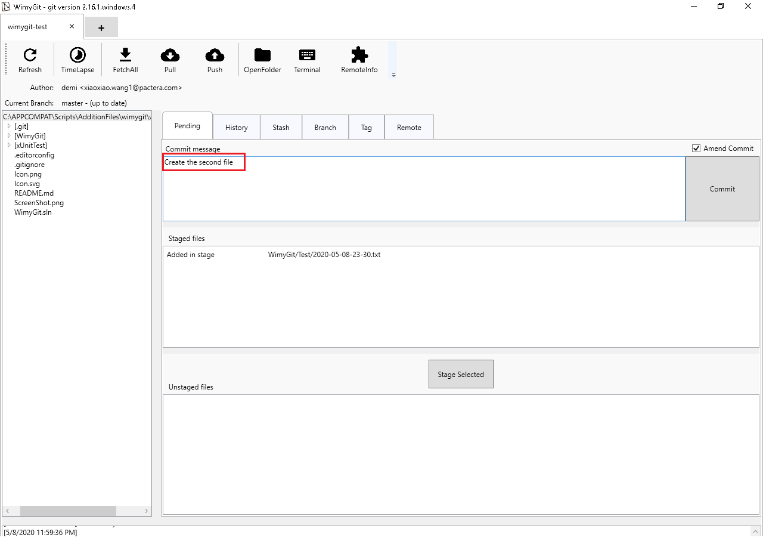

1. Click the “Commit” button.

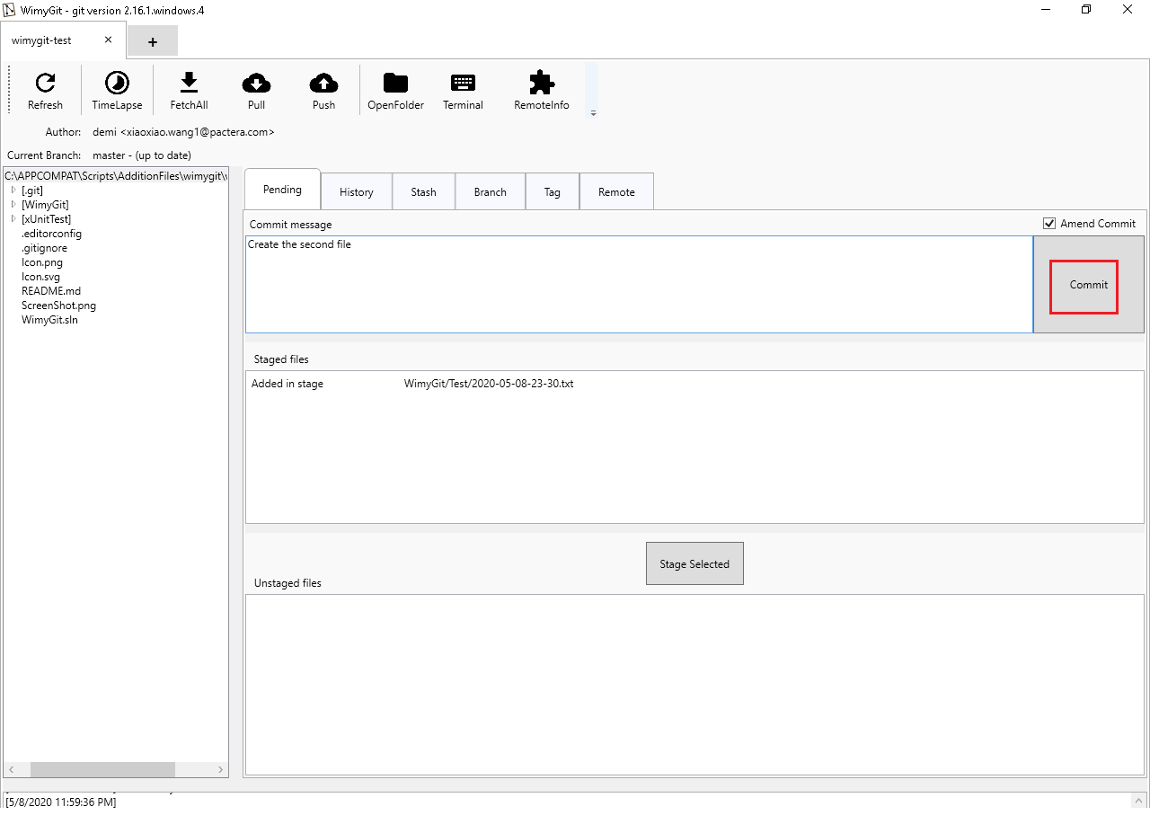

1. Click “Pull” button.

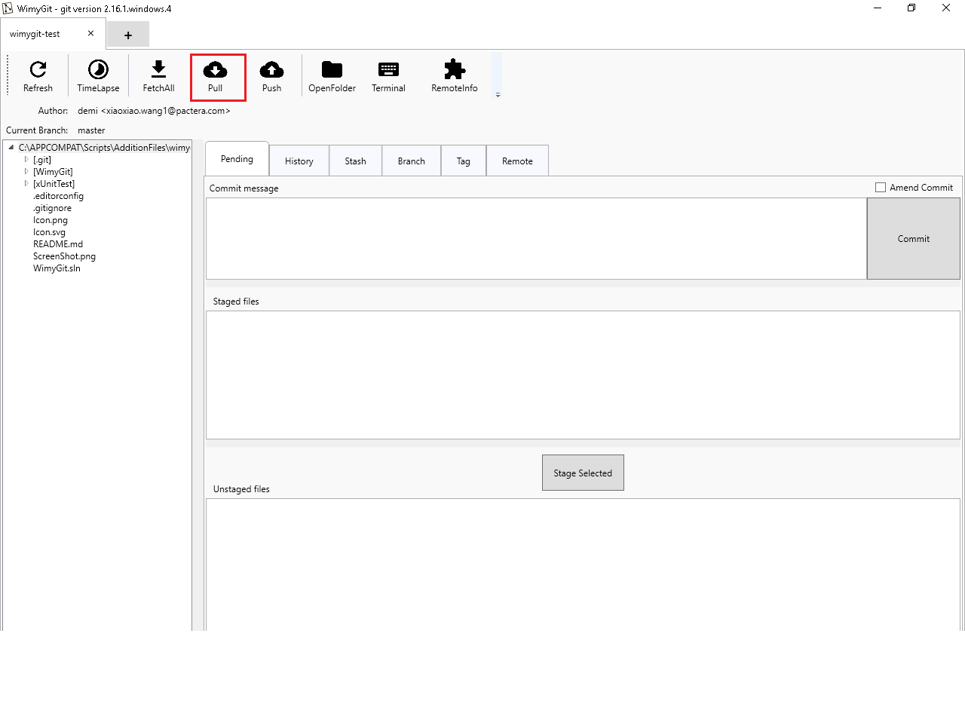

1. **Verify**: There is a “Process exited with success” stentence in the window.

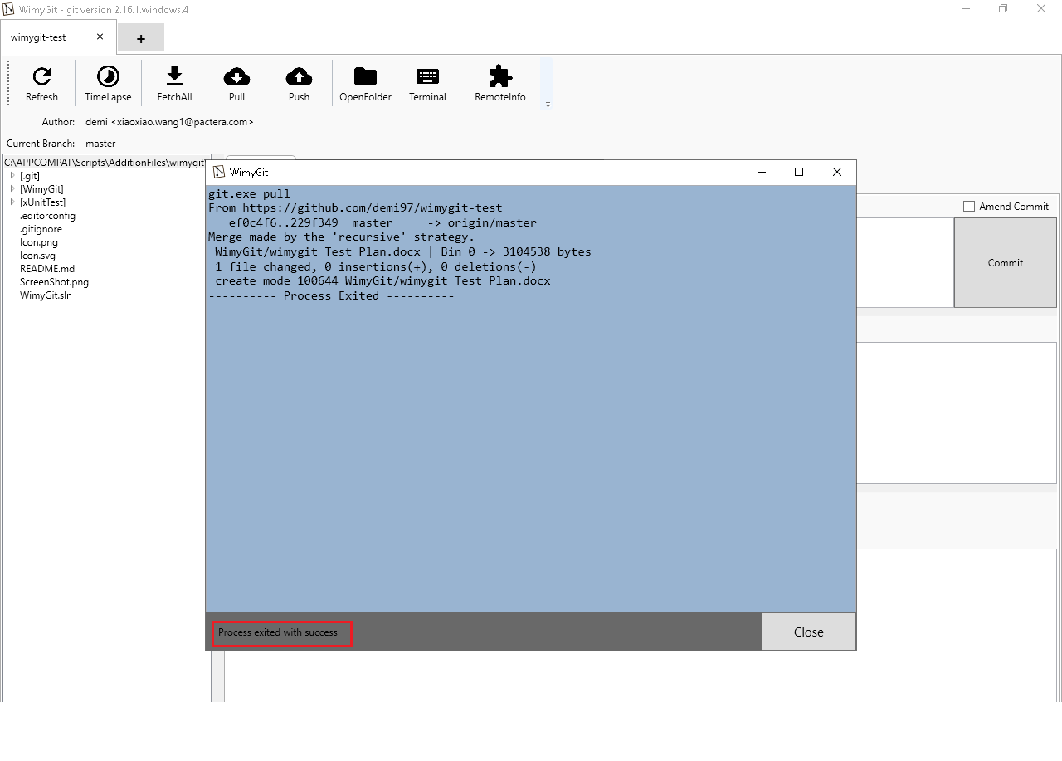

1. Click the “Close” button to close the window.

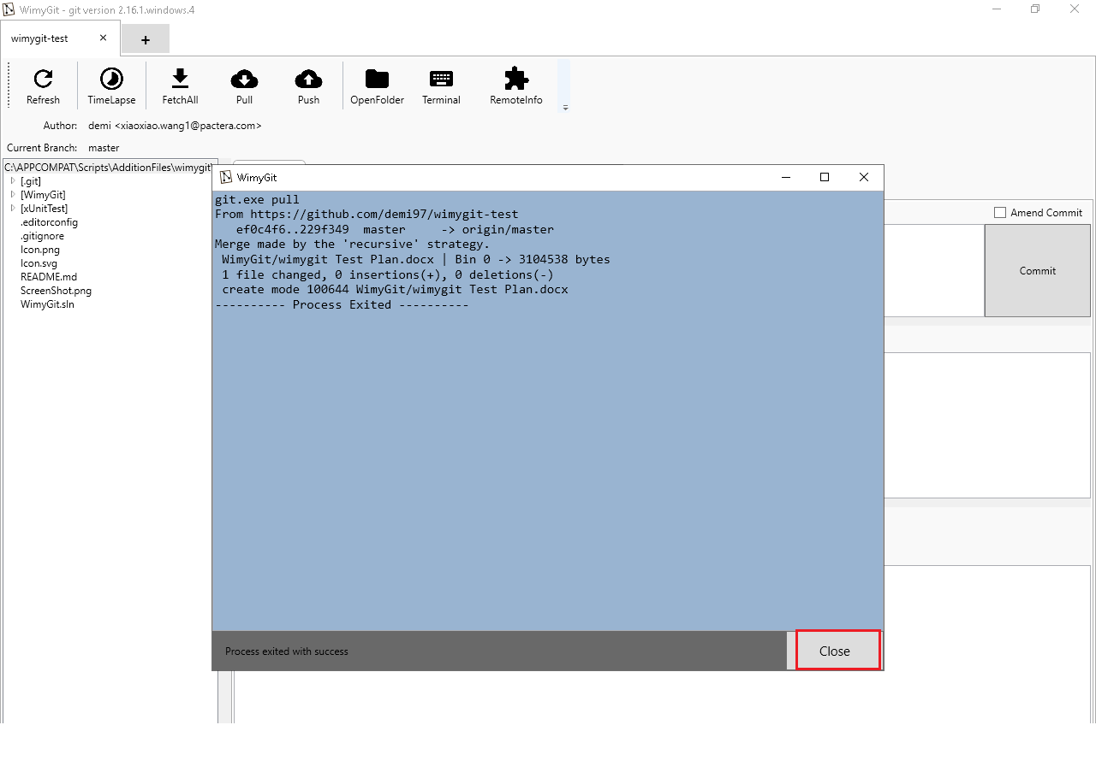

1. Click the “Push” button.

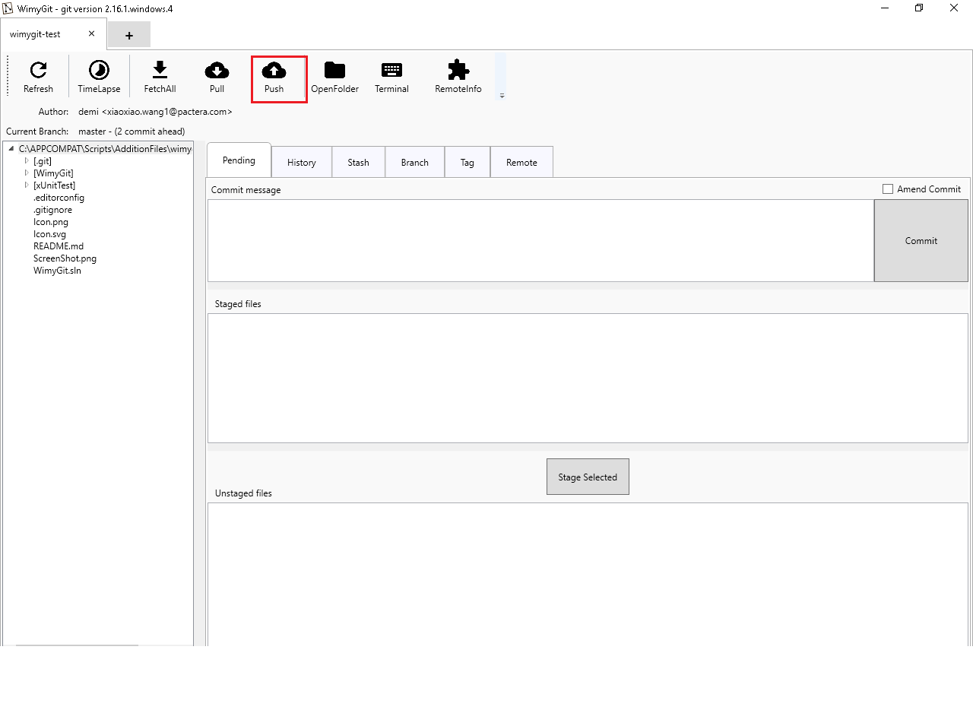

1. **Verify**: There is a “Process exited with success” stentence in the window.

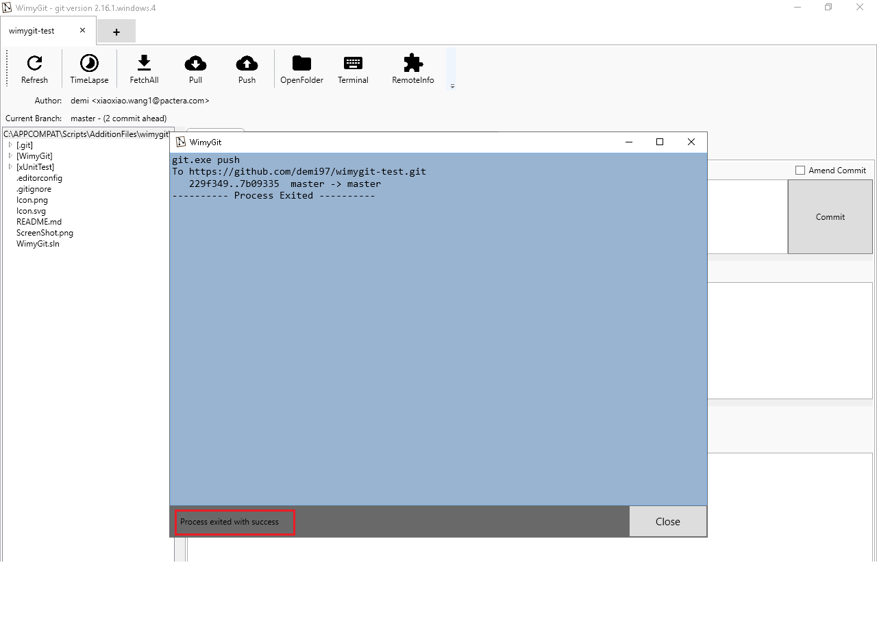

1. Click the “Close” button to close the window.

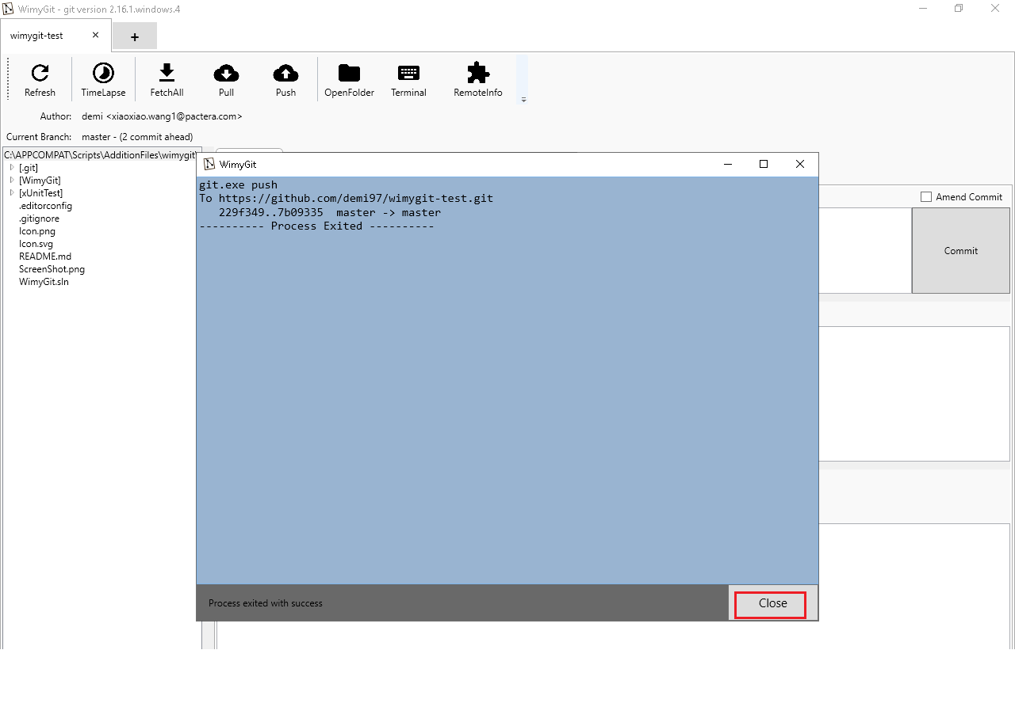

1. Close the “wimygit-test” tab.



1. Close the app.



# Issues

No issue